v

**submitted to:**

**Mr. Anish Bansal**

**Submitted by:**

**sanskriti chaturvedi**

**COMPUTER SCIENCE**

**PRACTICAL FILE**

**13685246**



**PYTHON**

**INDEX**

|  |  |  |
| --- | --- | --- |
| S. No. | Content | Pg no. |
| 1 | Add, sub, even odd with no parameters. | 3-4 |
| 2 | Programme 1 with parameters. | 5-6 |
| 3 | Programme 2 with return. | 7-8 |
| 44 | Fibonacci sequence. | 9 |
| 5 | Armstrong number. | 10 |
| 6 | Dice simulator. | 11-12 |
| 7 | Count Me and My. | 13 |
| 8 | Count A,a and M,m. | 14-15 |
| 9 | Stacks. | 16-17 |
| 10 | Count vowels. | 18 |

|  |  |  |
| --- | --- | --- |
| S. No. | Content | Pg no. |
| 11 | Read, write and append a text file. | 19-22 |
| 12 | Read, write and append a csv file. | 23-26 |
| 13 | Pickle module. | 27 |
| 14 | Remove lines containing ‘a’ from a text file and writing them to another file. | 28-29 |
| 15 | Binary file- write, read and update. | 30-32 |
| 16 | Binary file- write, read and search. | 33-35 |
| 17 | MySQL.connector- Connection. | 36 |
| 18 | MySQL.connector- Database. | 37 |
| 19 | MySQL.connector- Insert. | 38-39 |
| 20 | MySQL.connector- Select. | 40-41 |

**INDEX**

#Program 1:

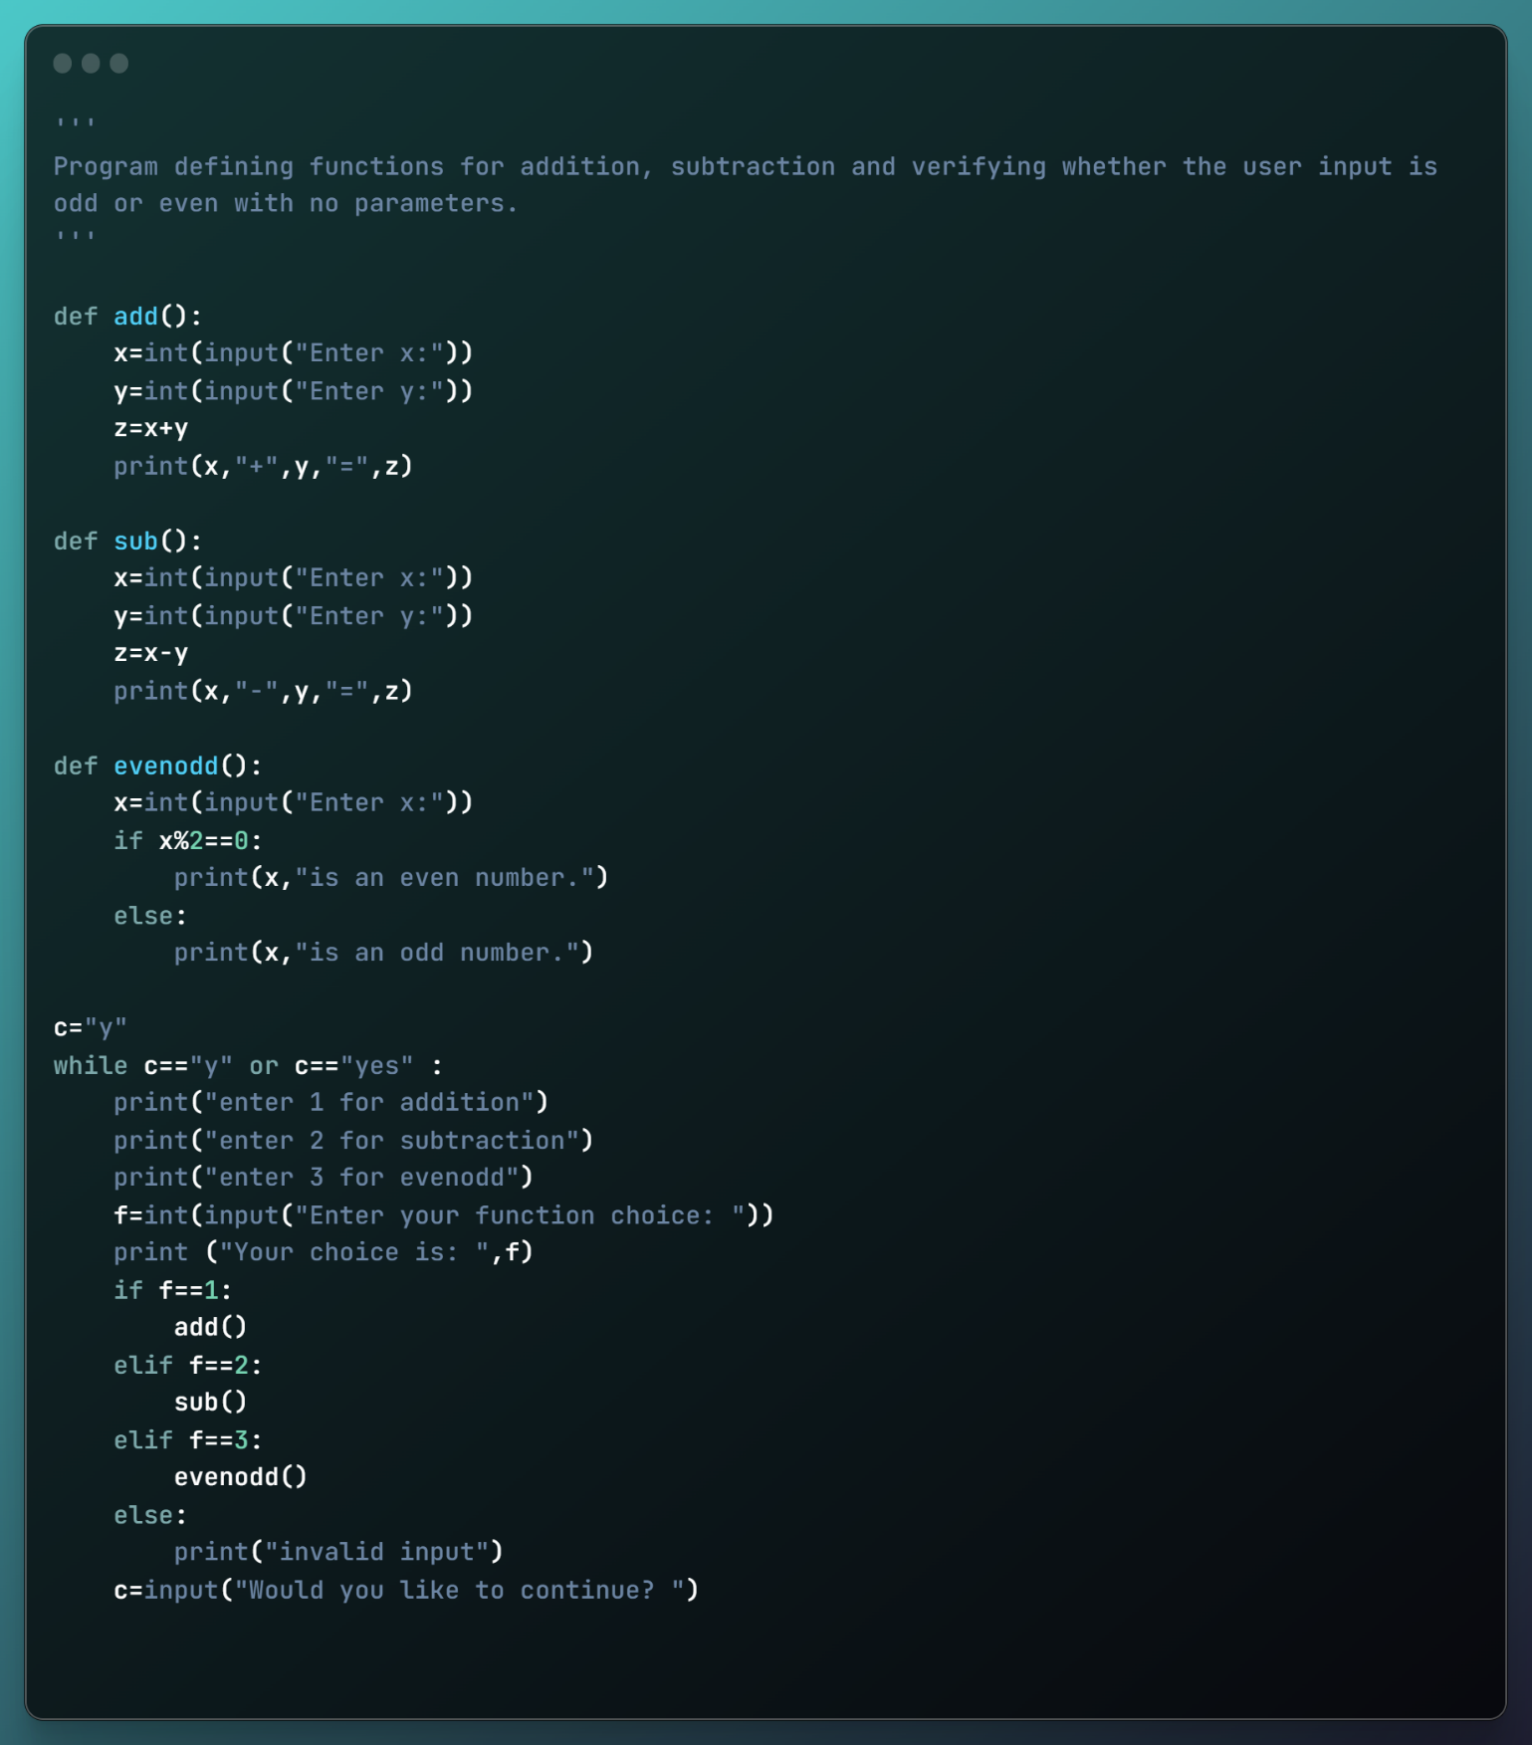

Output 1: 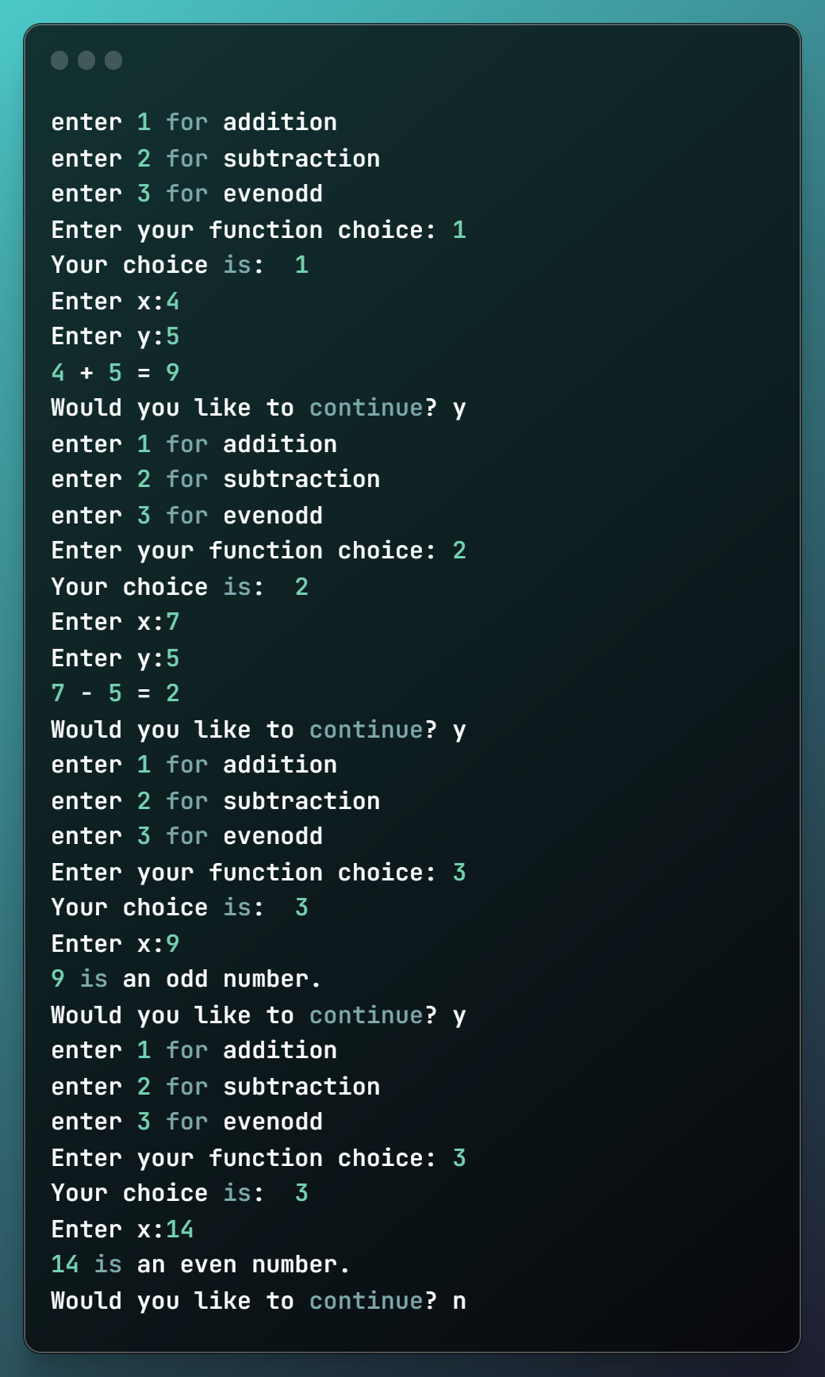

#Program 2:

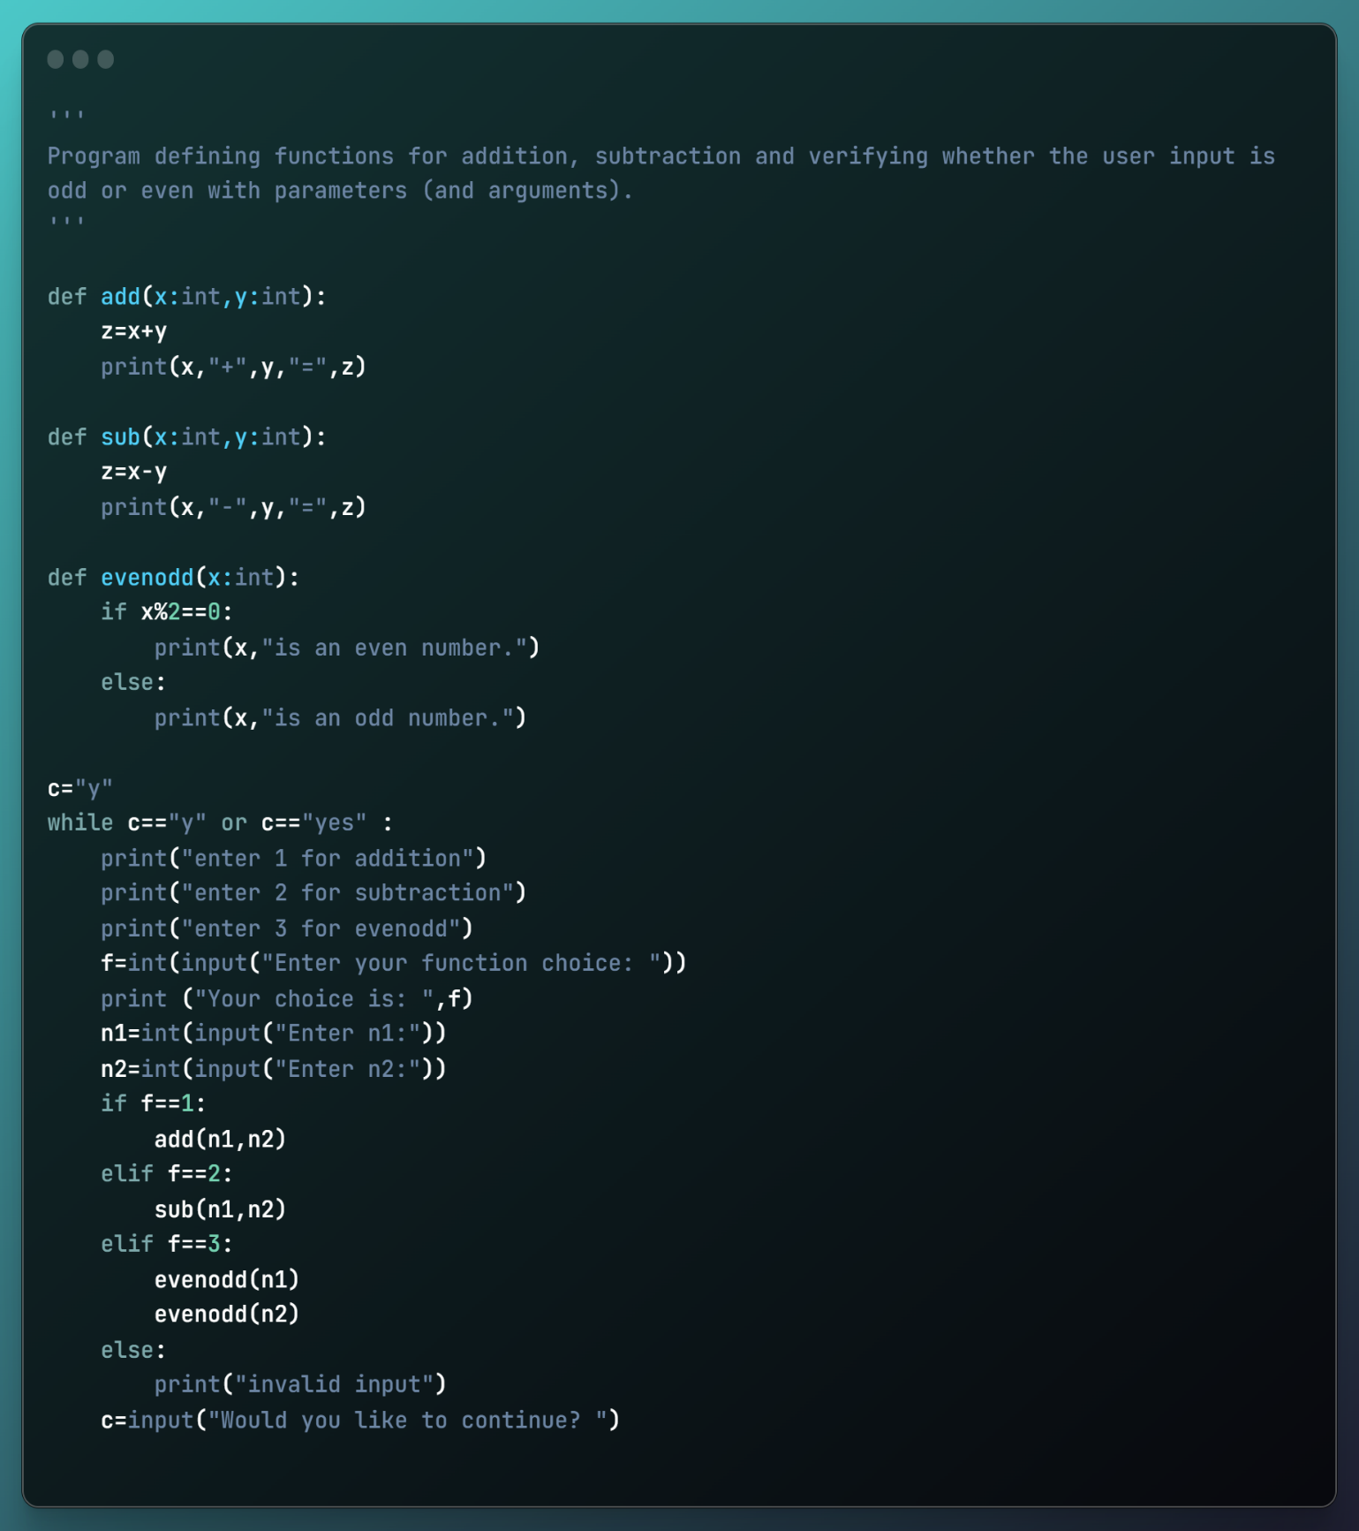

Output 2:

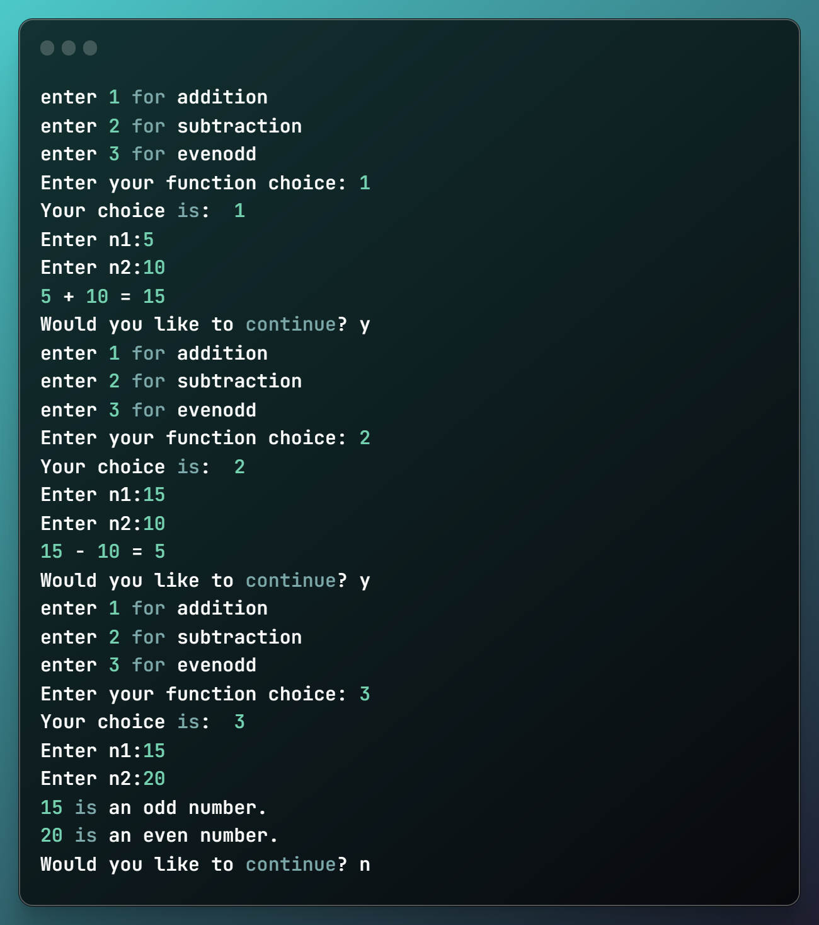

#Program 3:

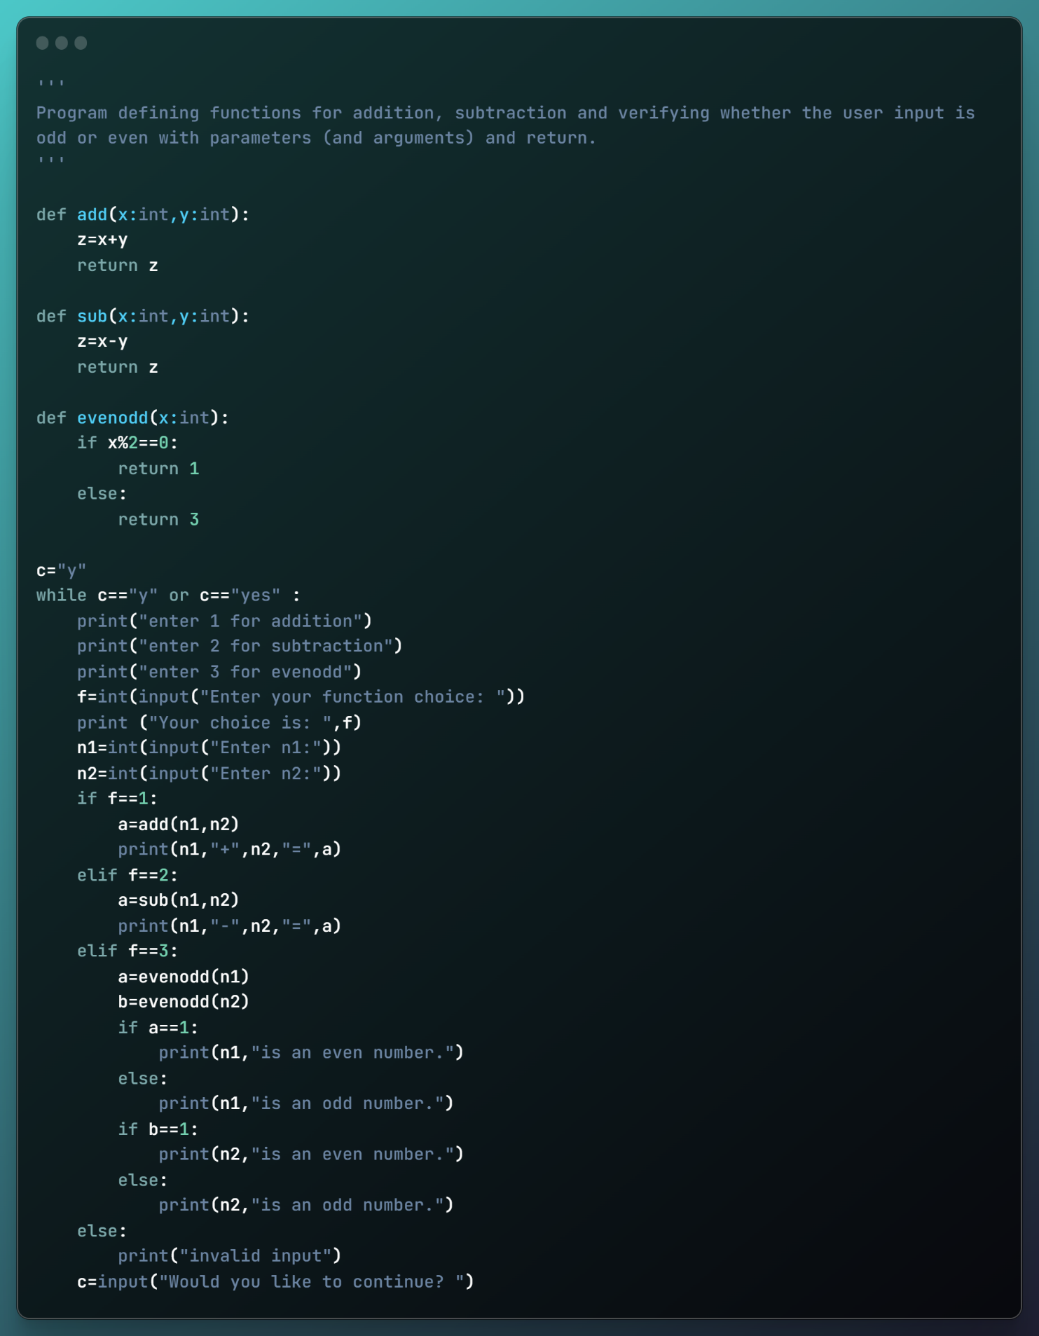

Output 3:

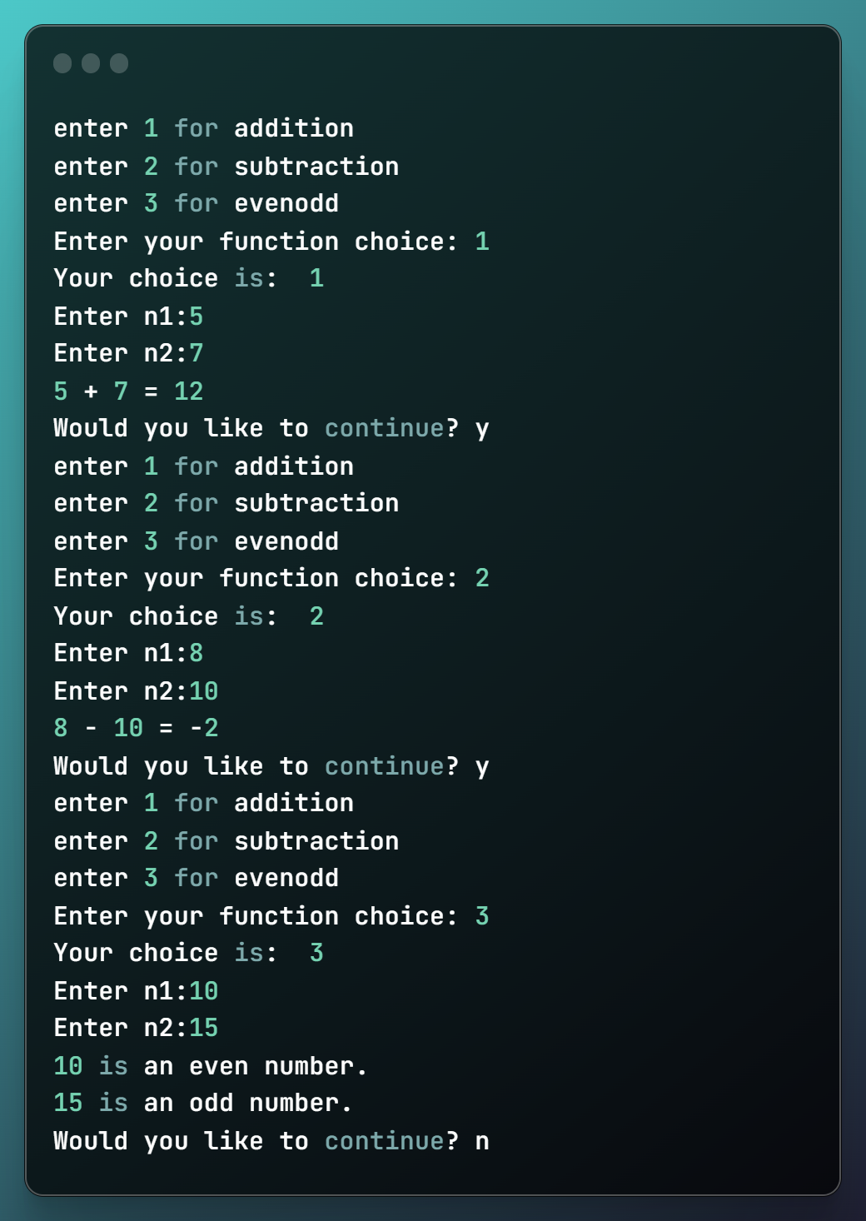

#Program 4:

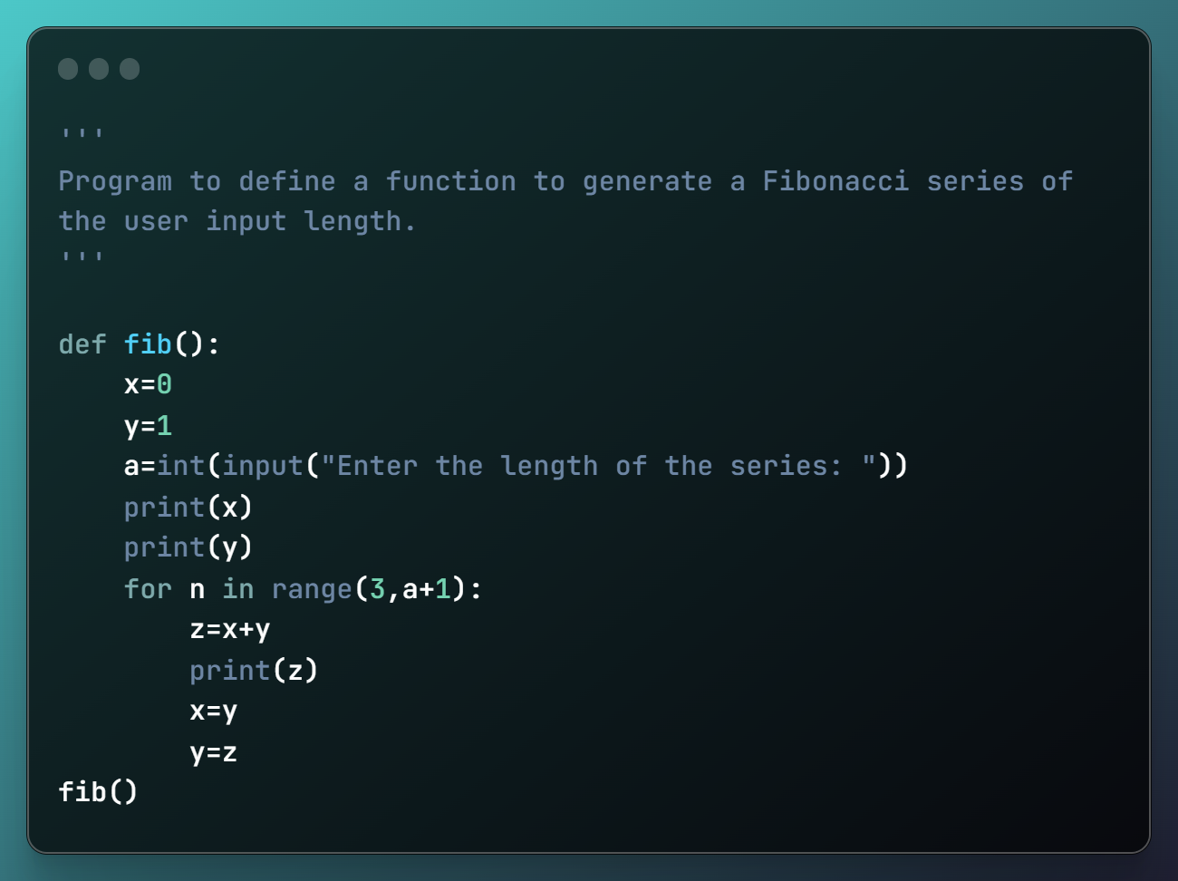

Output 4:

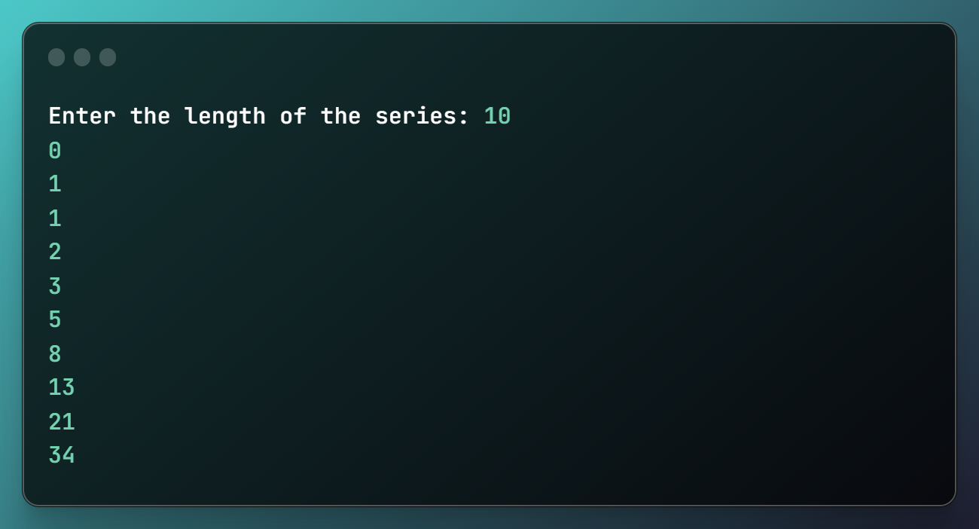

#Program 5:

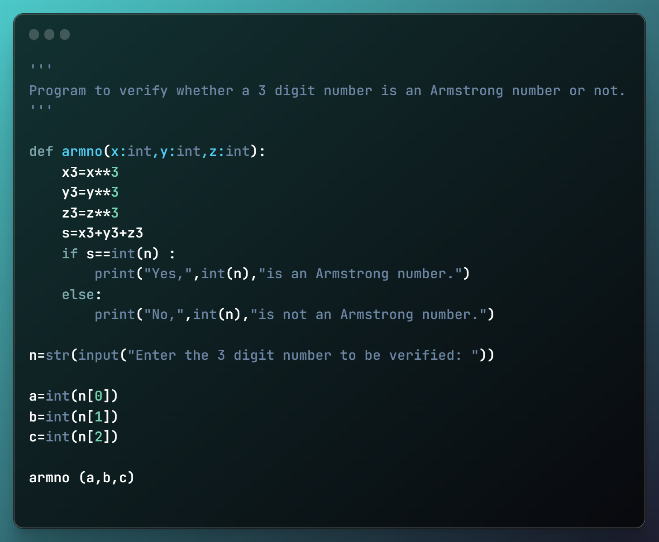

Output 5: 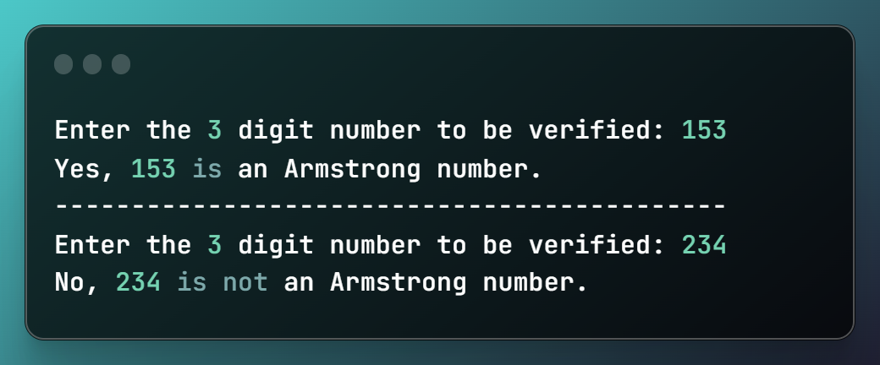

#Program 6: 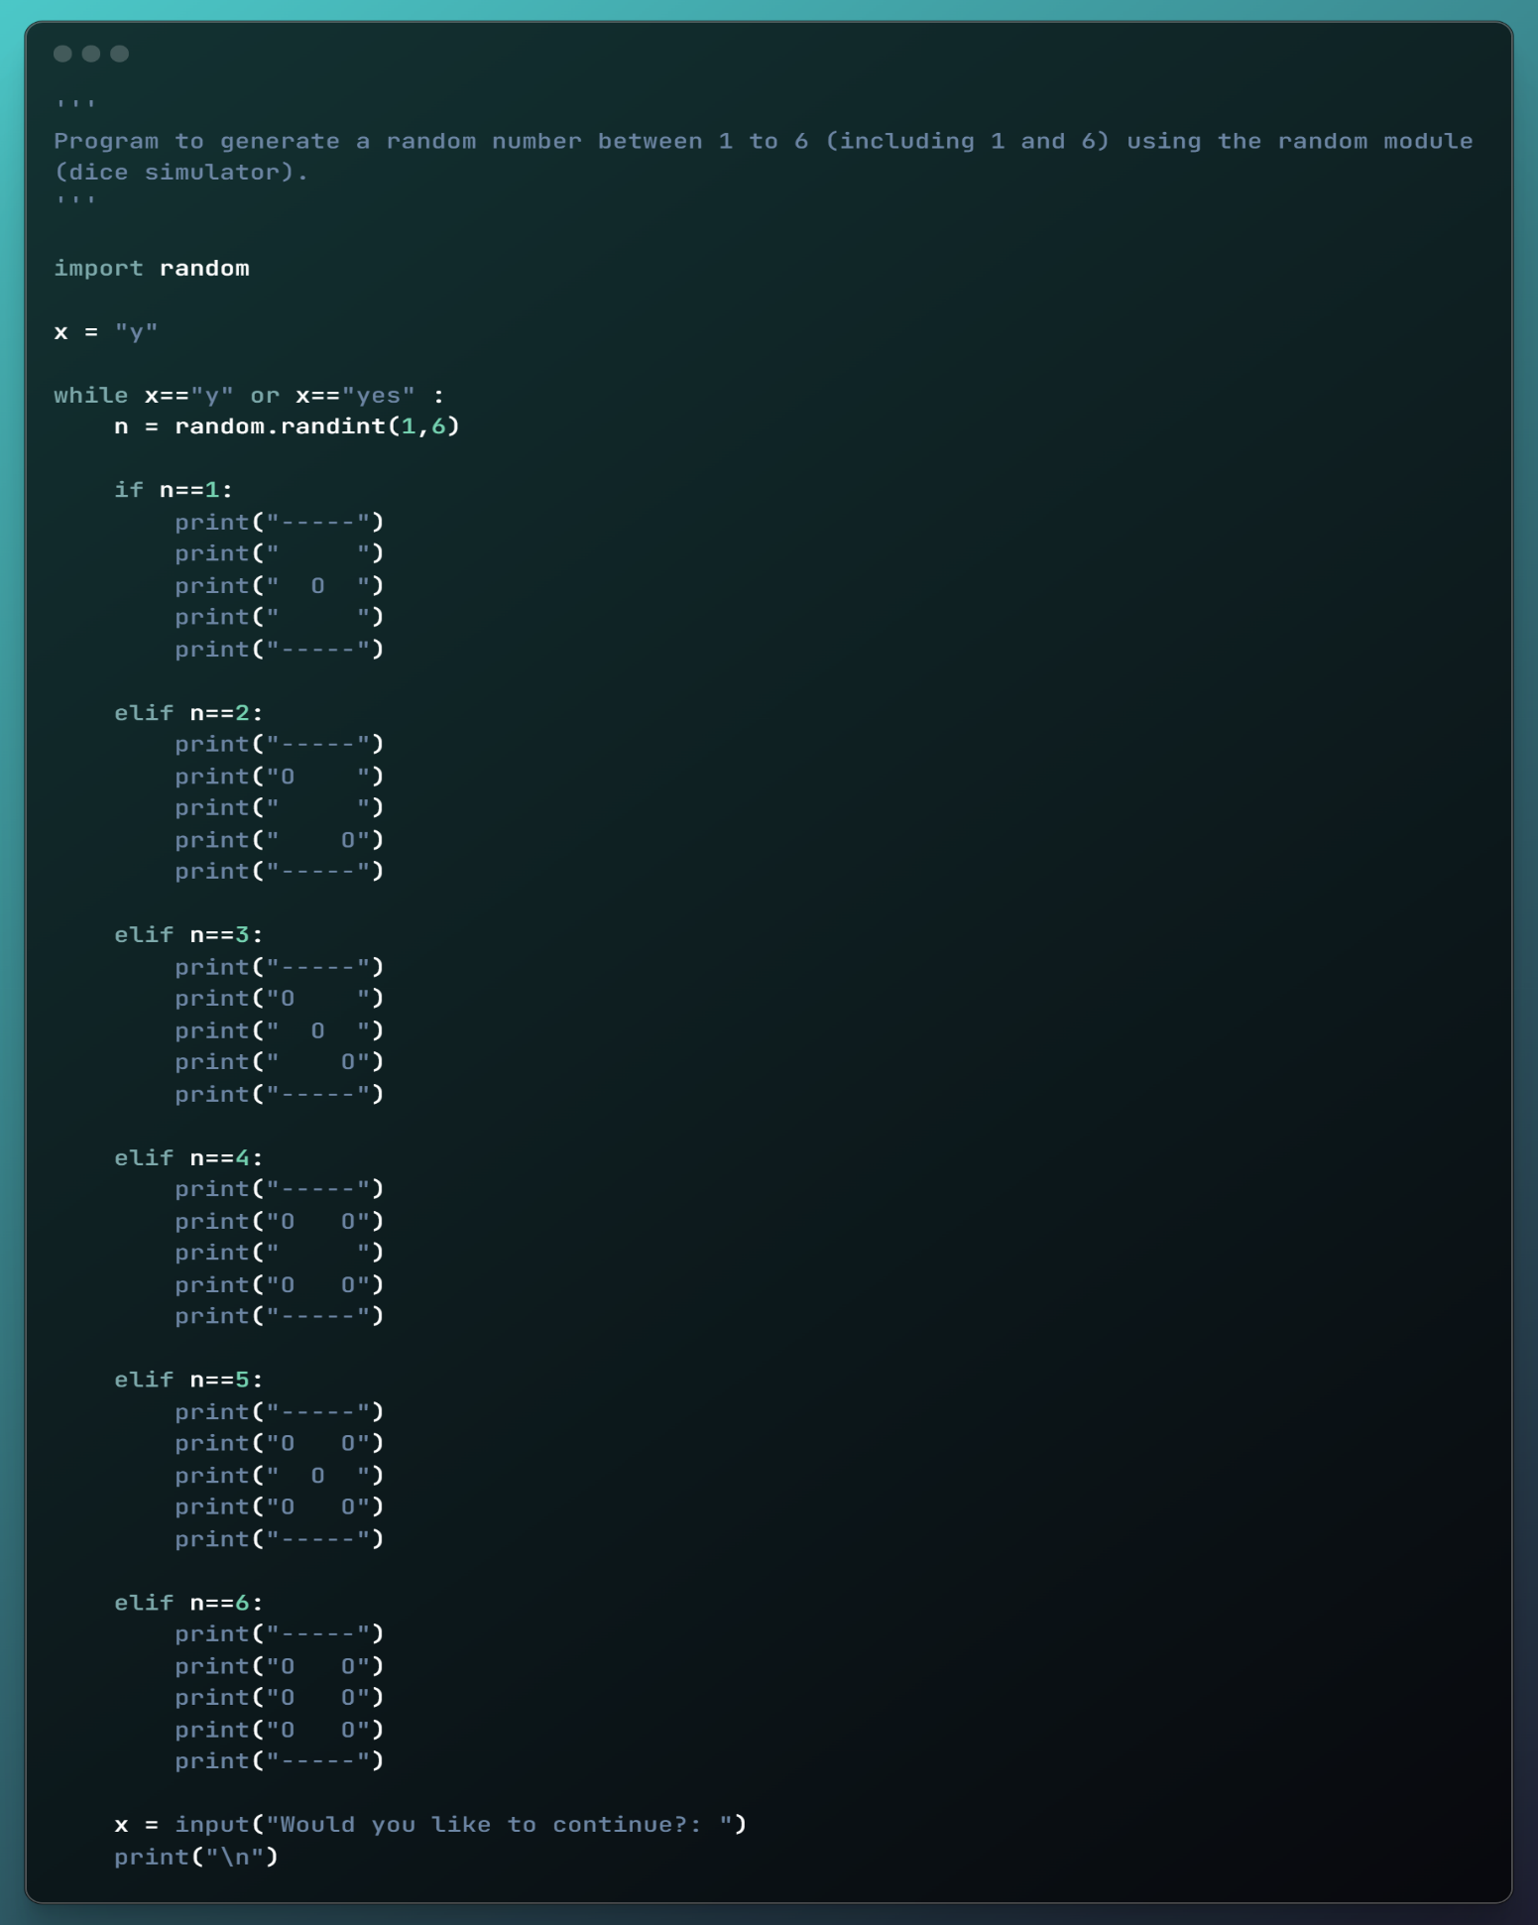

Output 6:

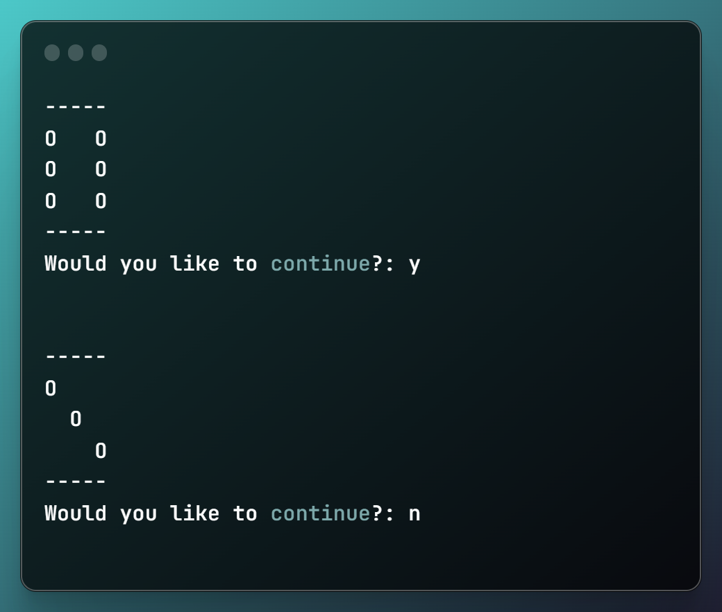

#Program 7:

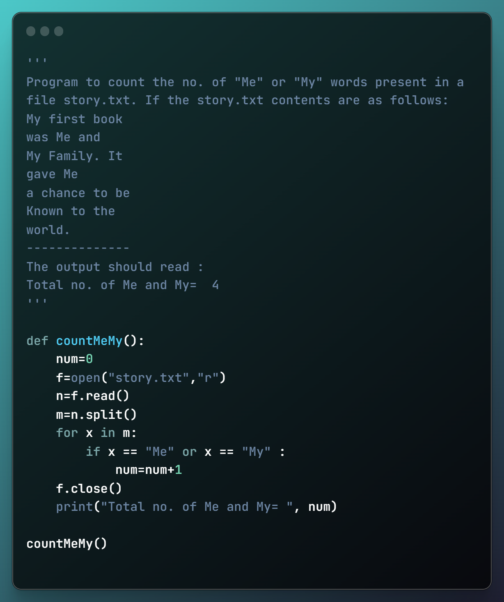

Output 7:

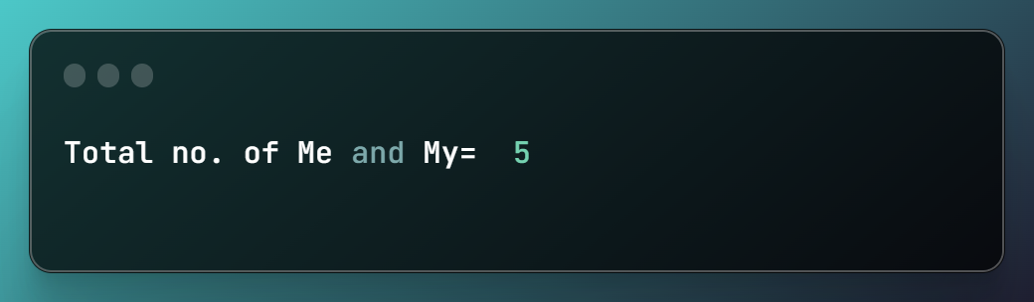

#Program 8:

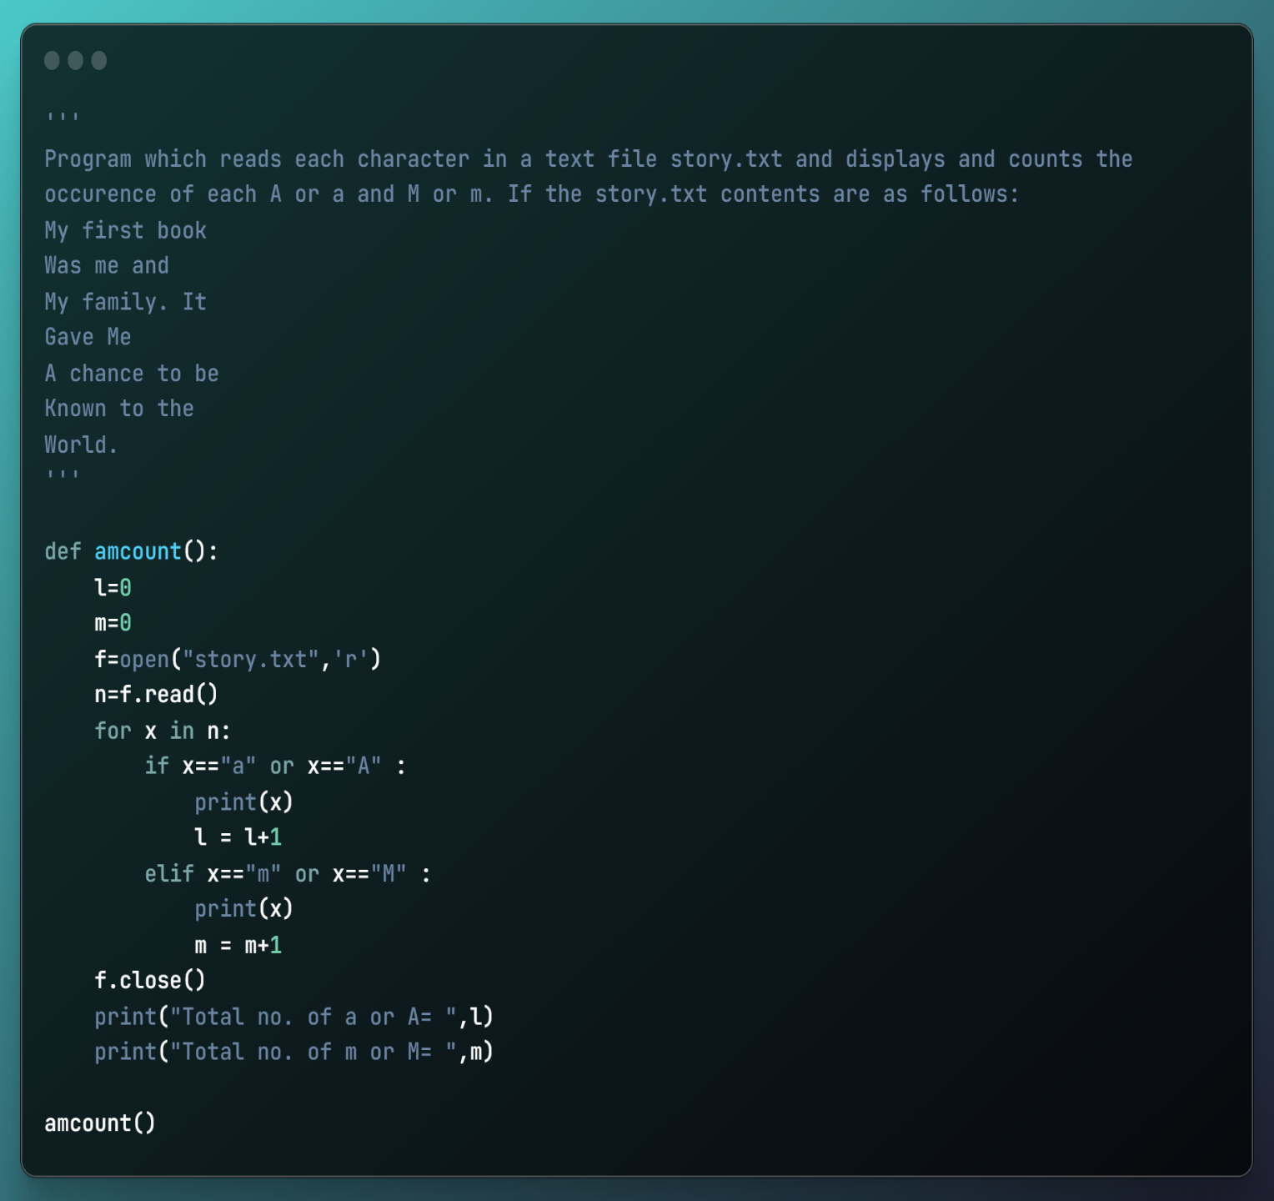

Output 8:

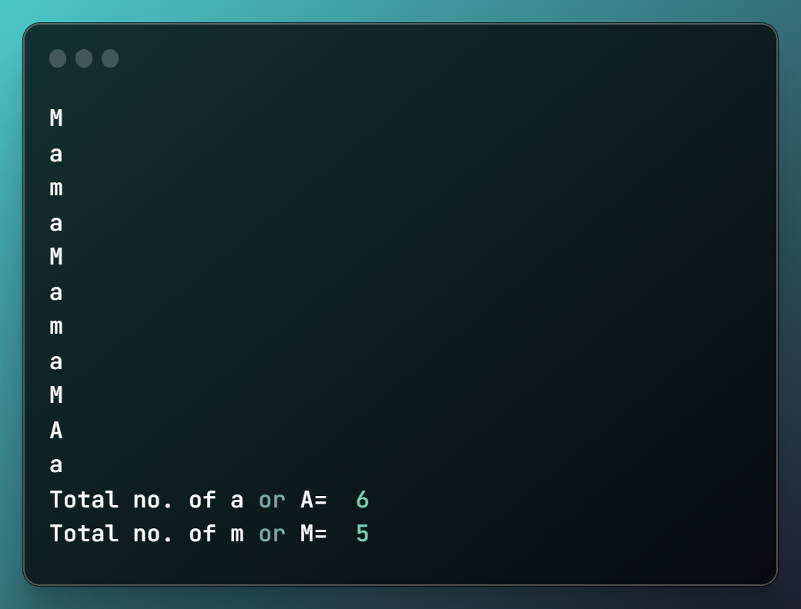

#Program 9: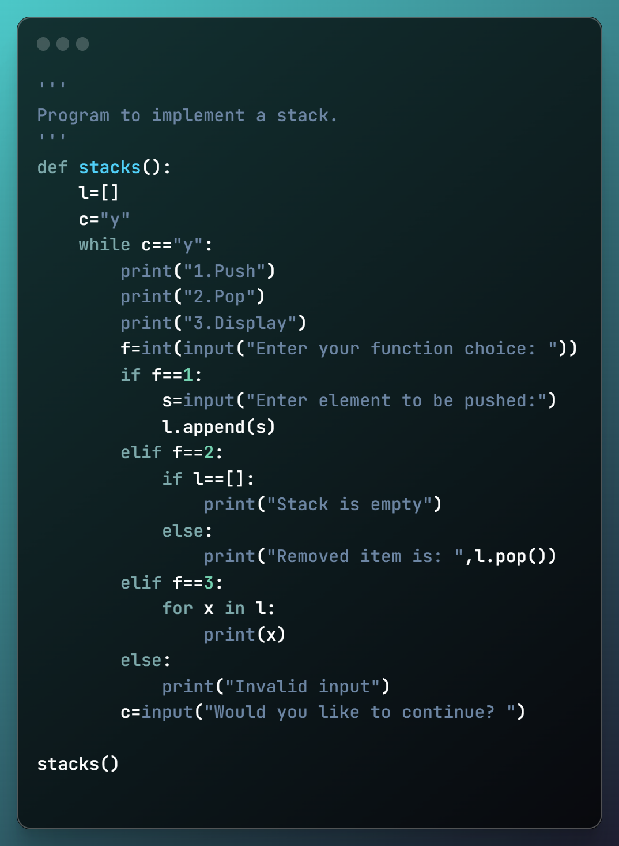 Output 9:

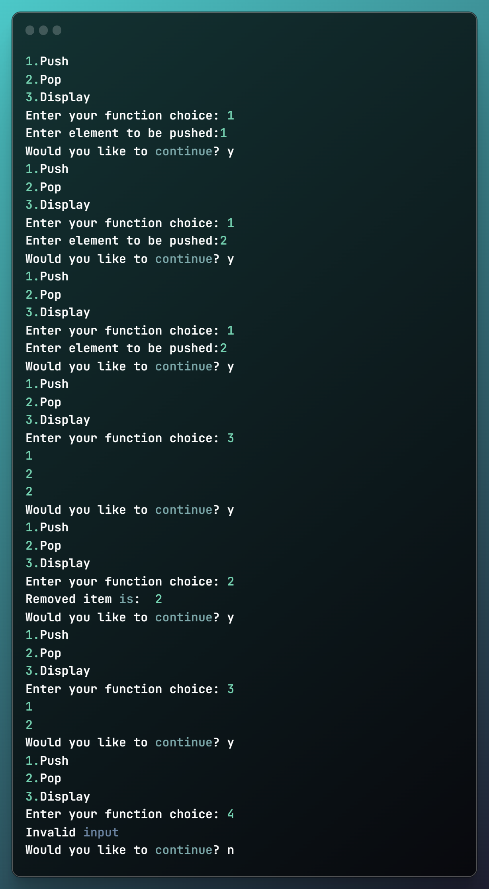

#Program 10:

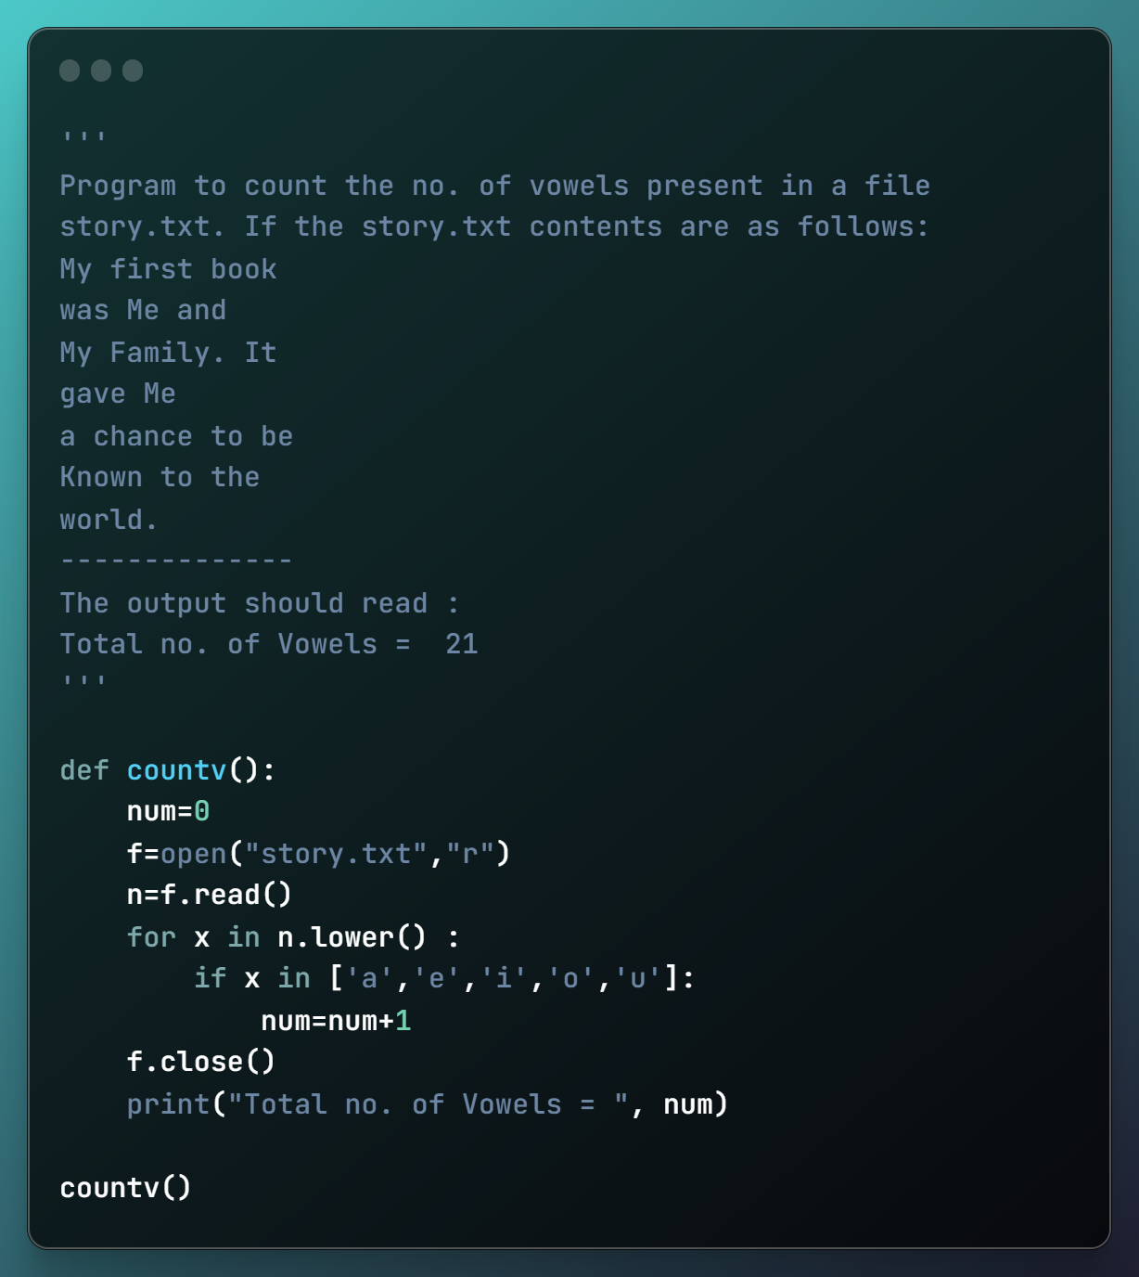

Output 10:

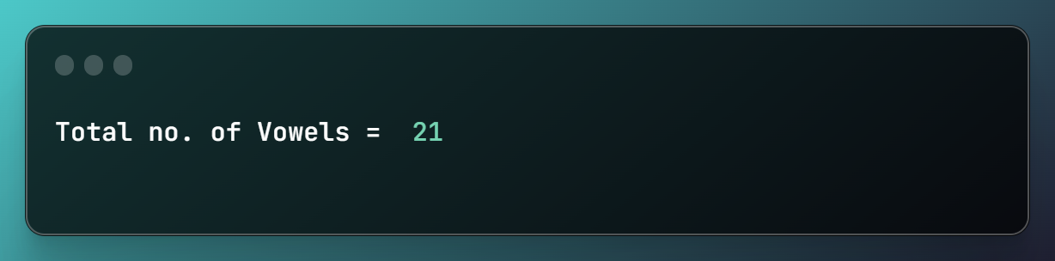

#Program 11: 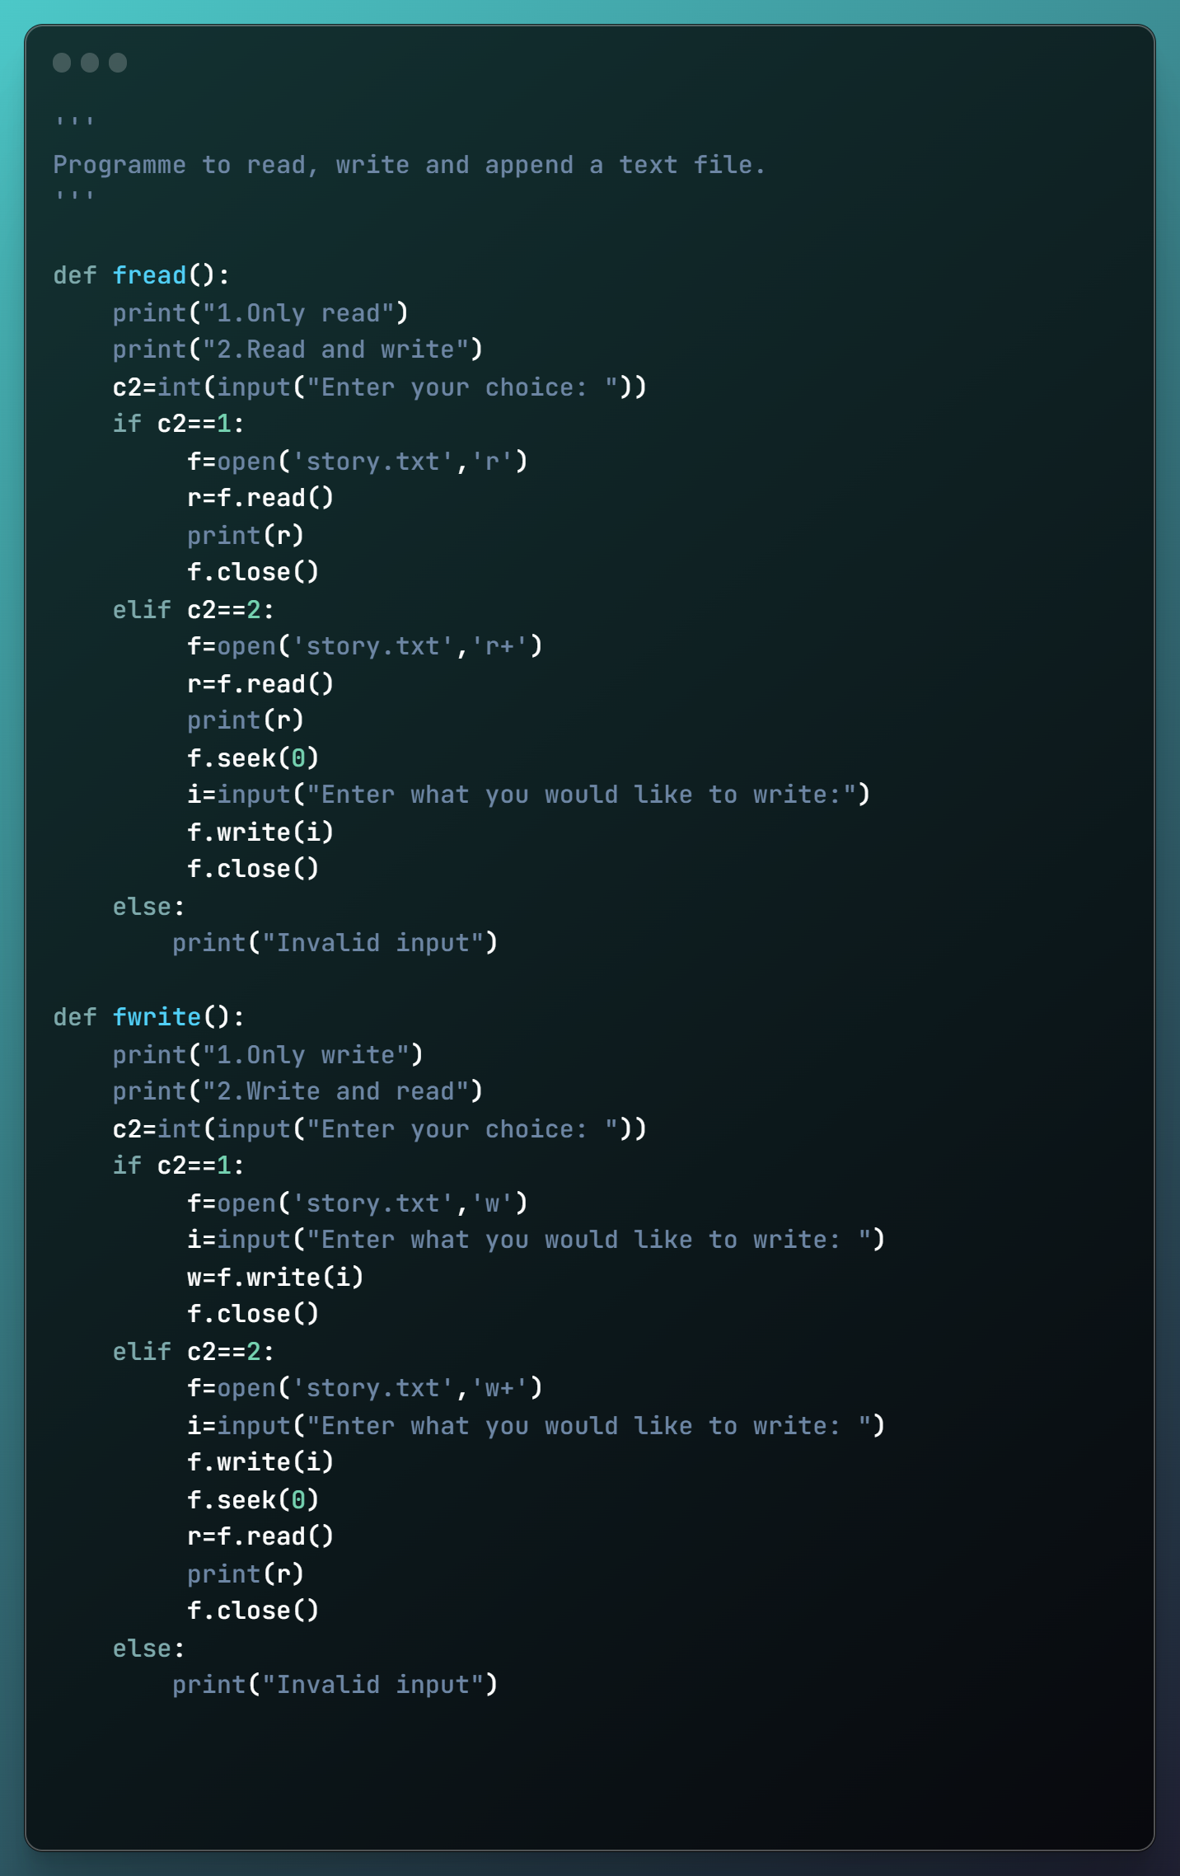

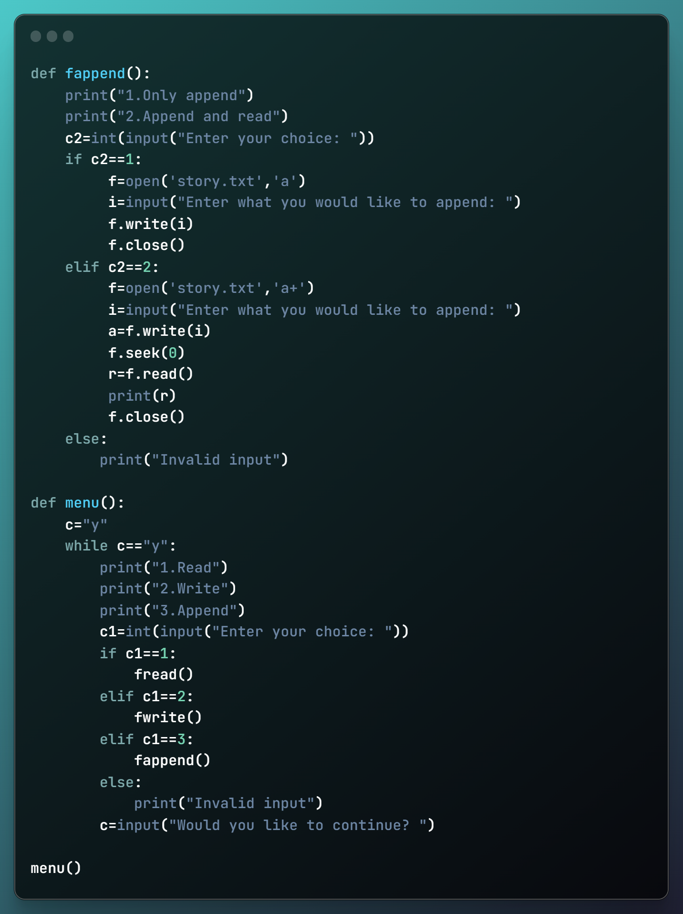

Output 11: 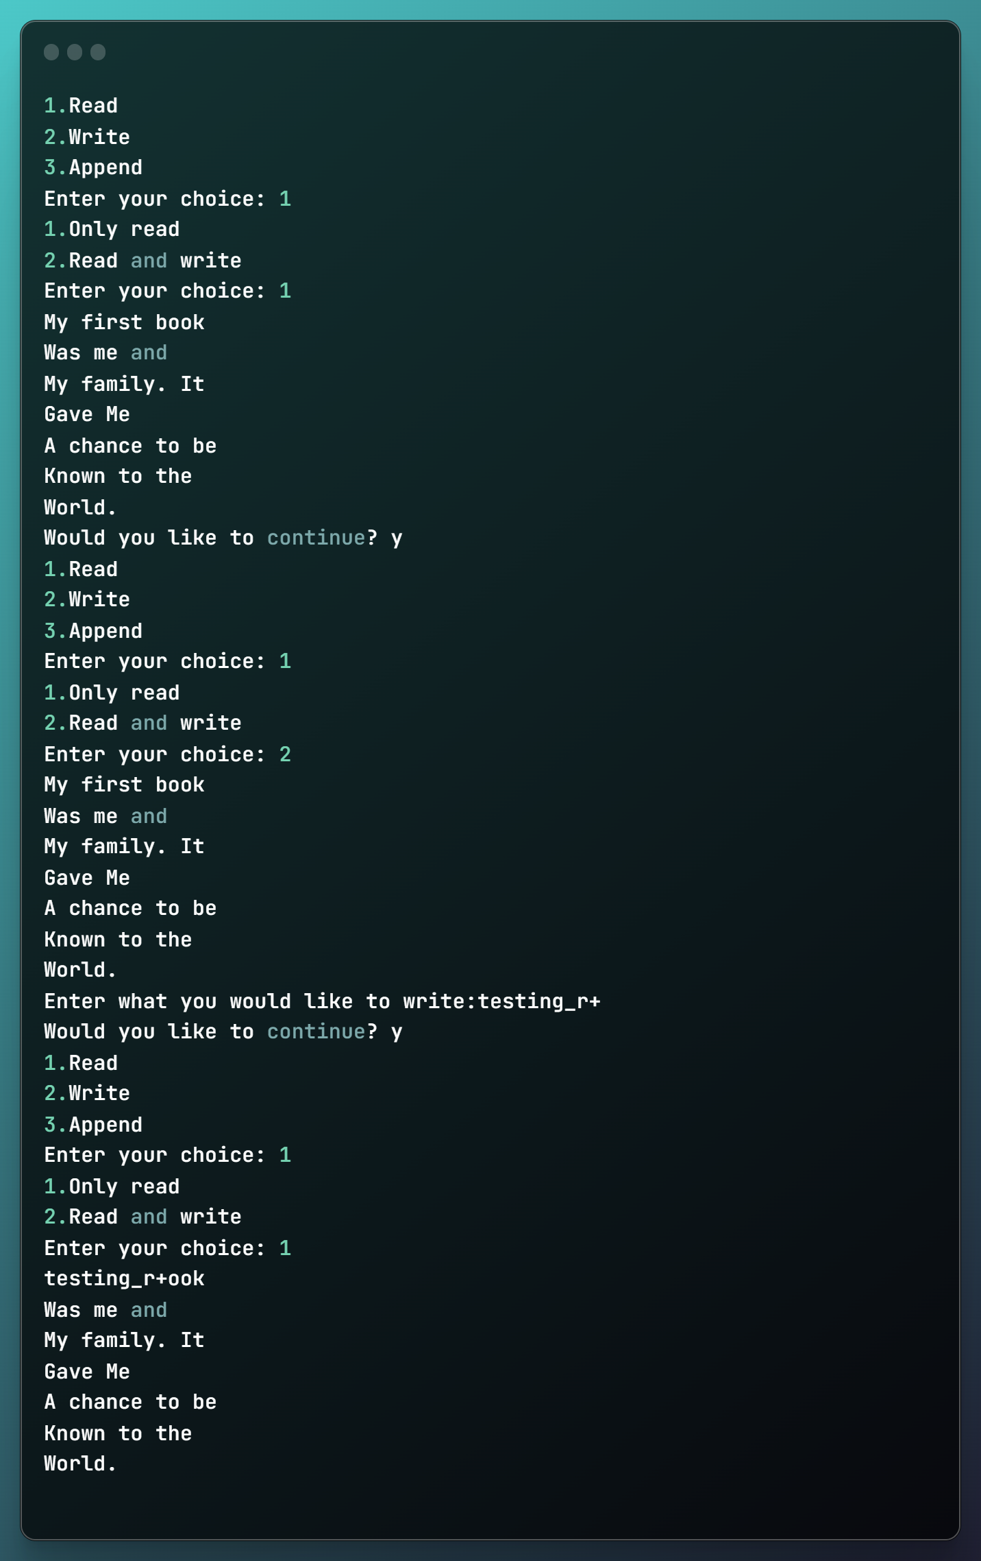

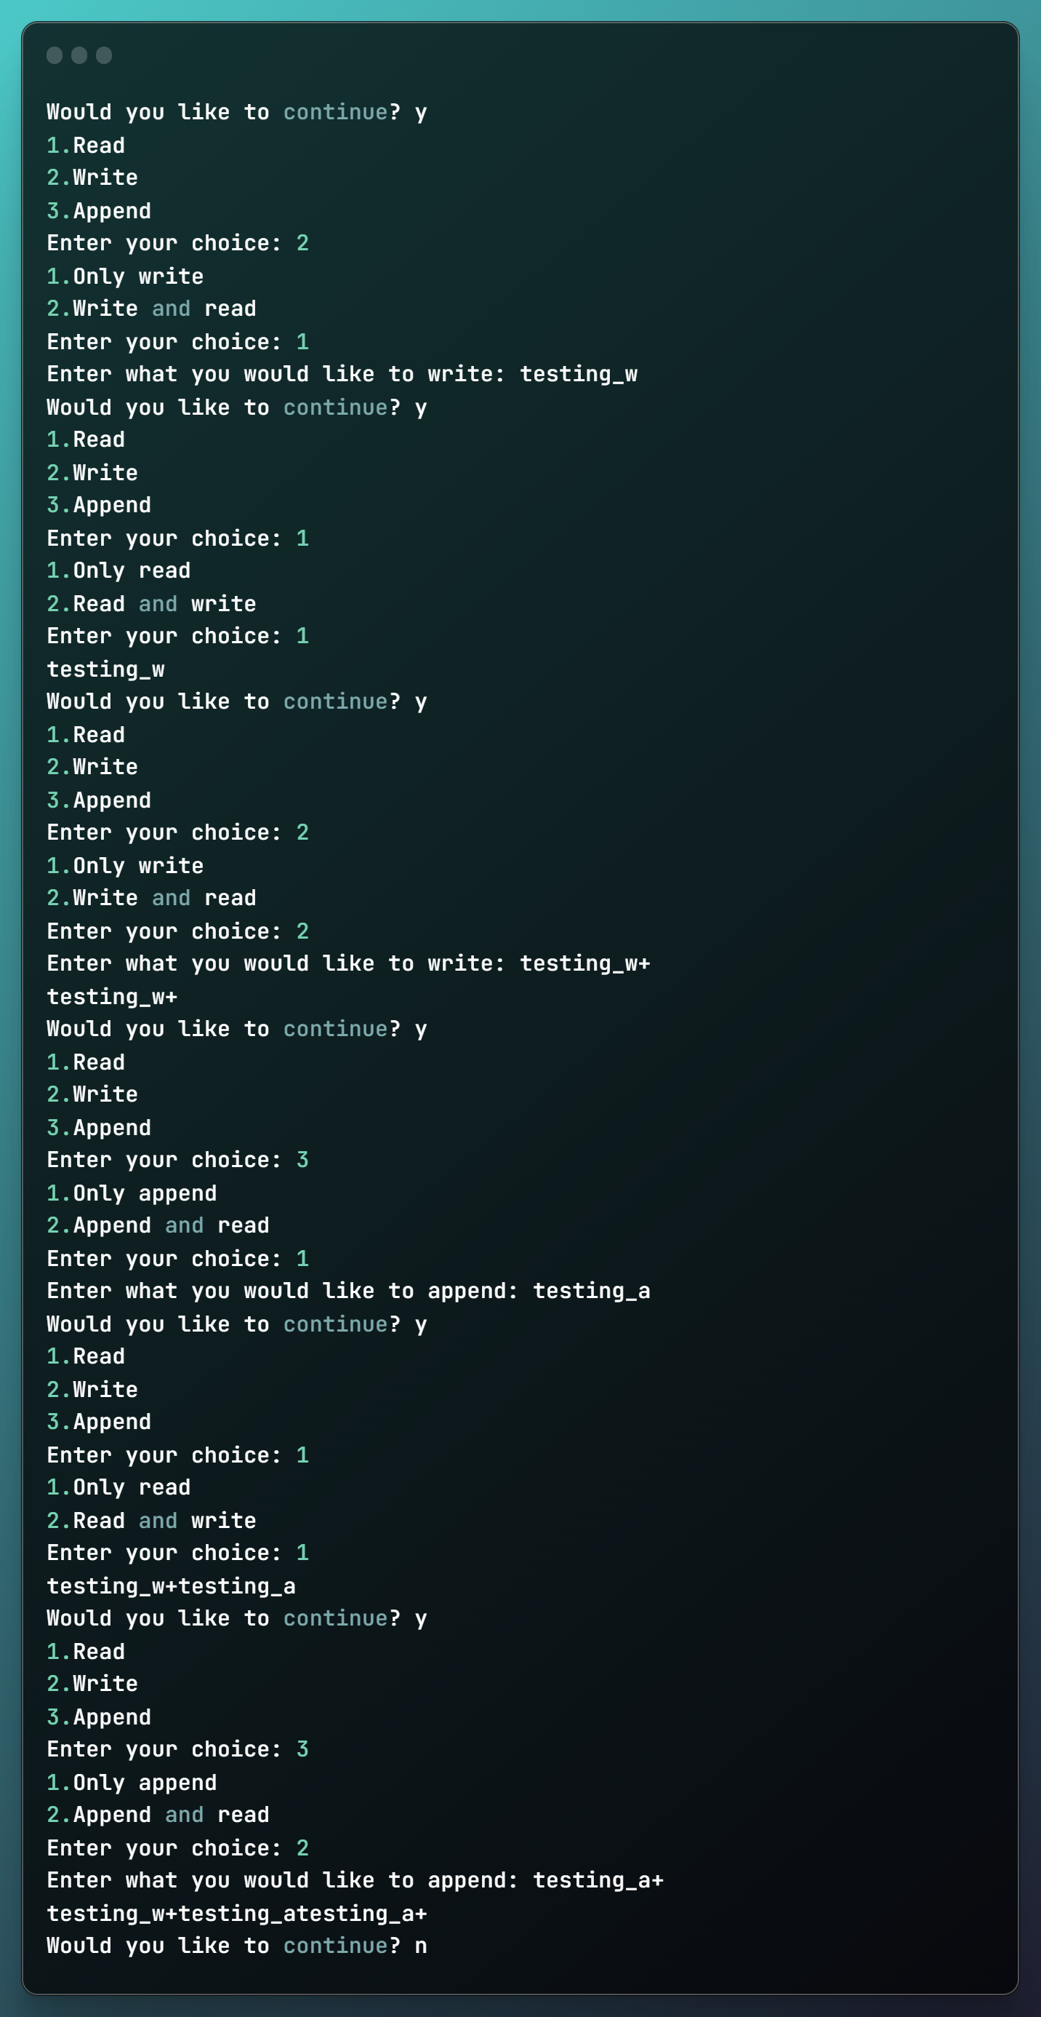

#Program 12:

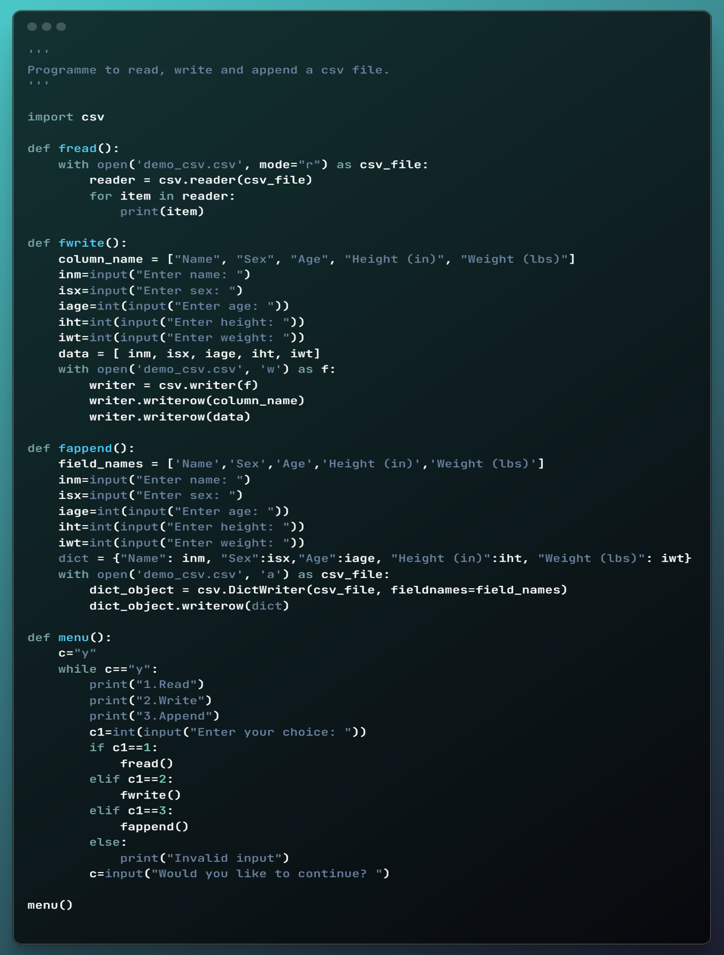

The following csv file demo _csv.csv is used in this programme:

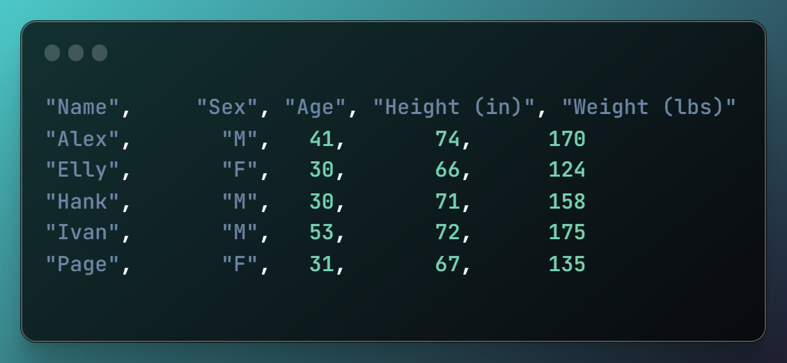

Output 12:

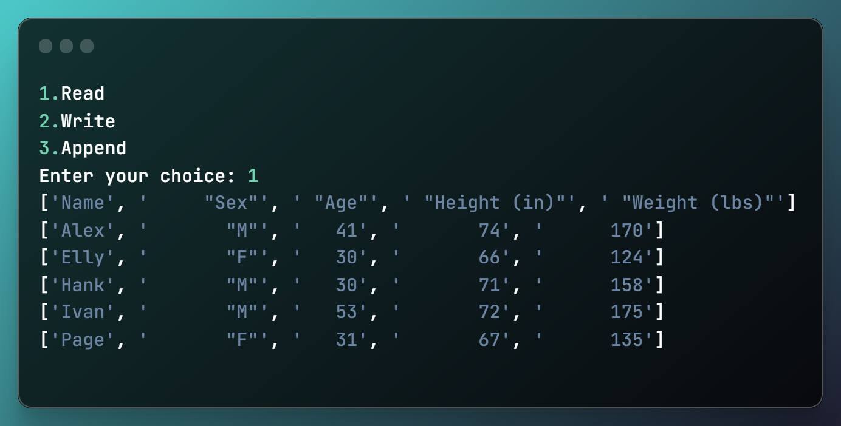

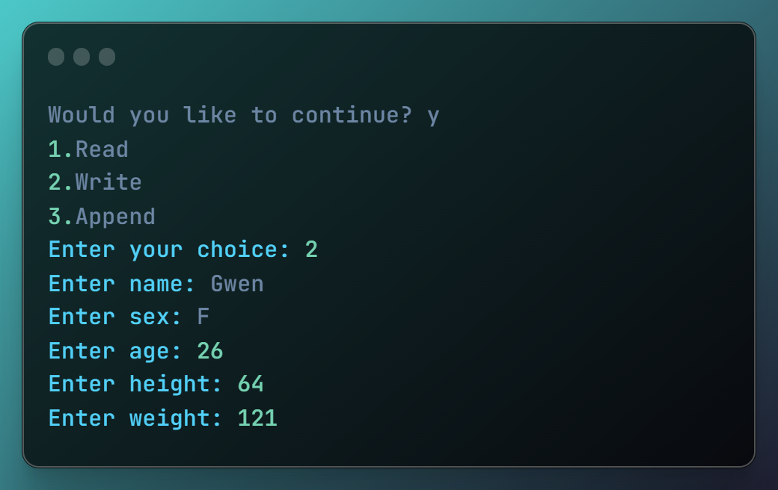

The csv file now reads: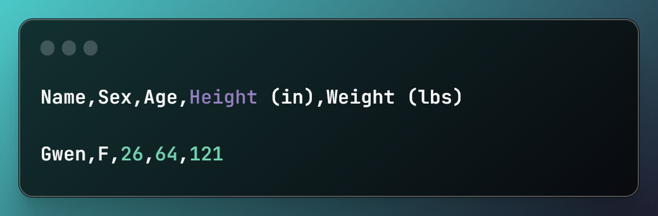

The terminal shows:

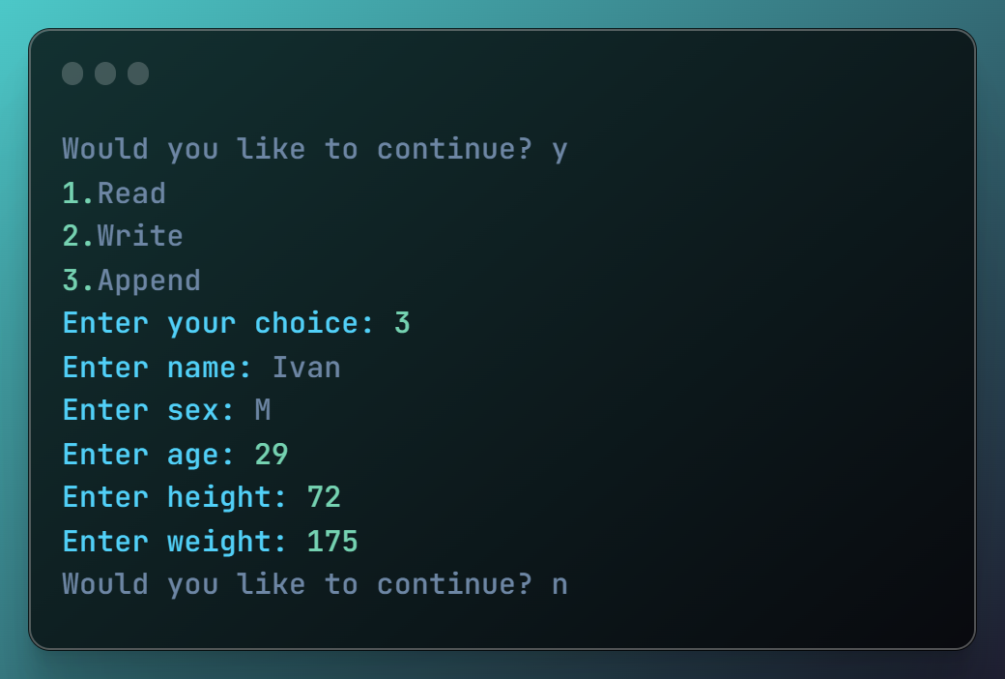

The csv file reads:

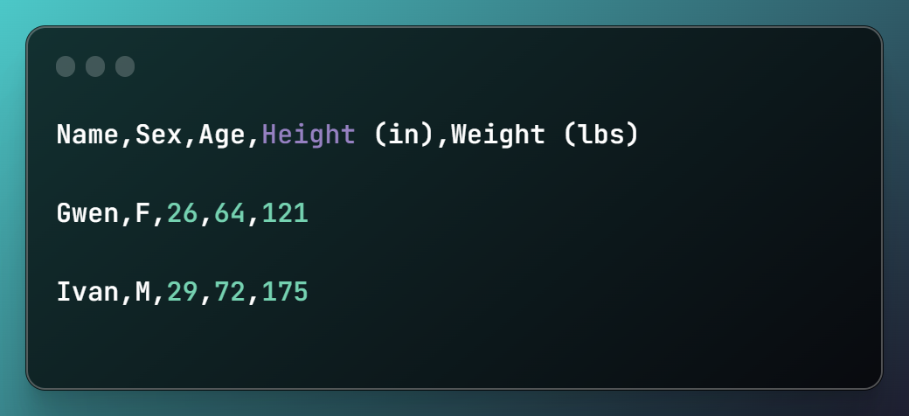

#Program 13:

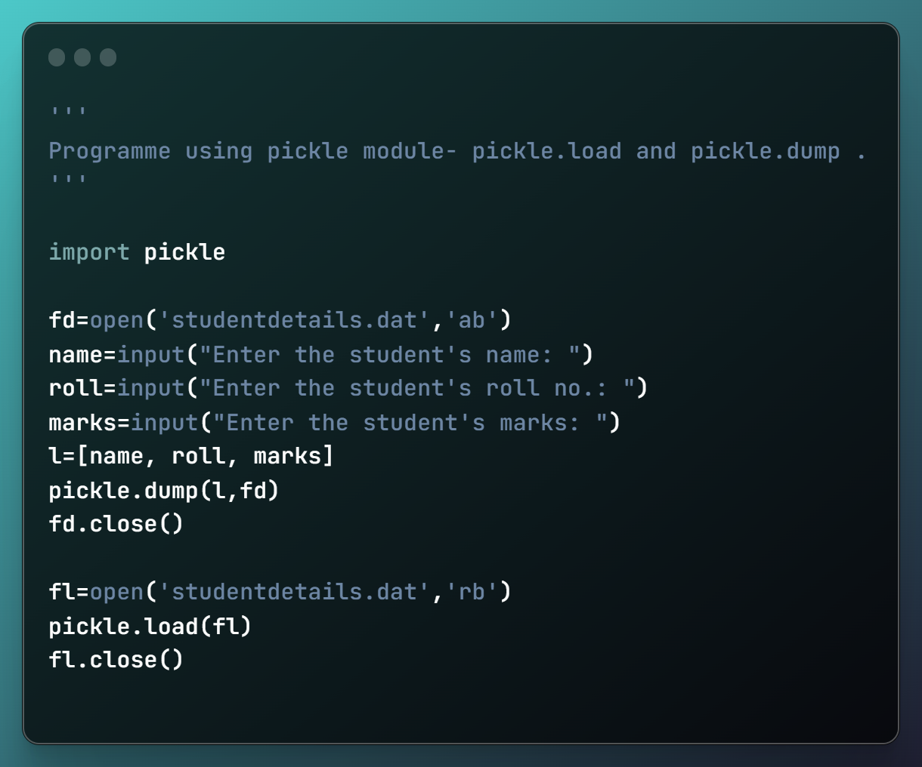

Output 13:



#Program 14:

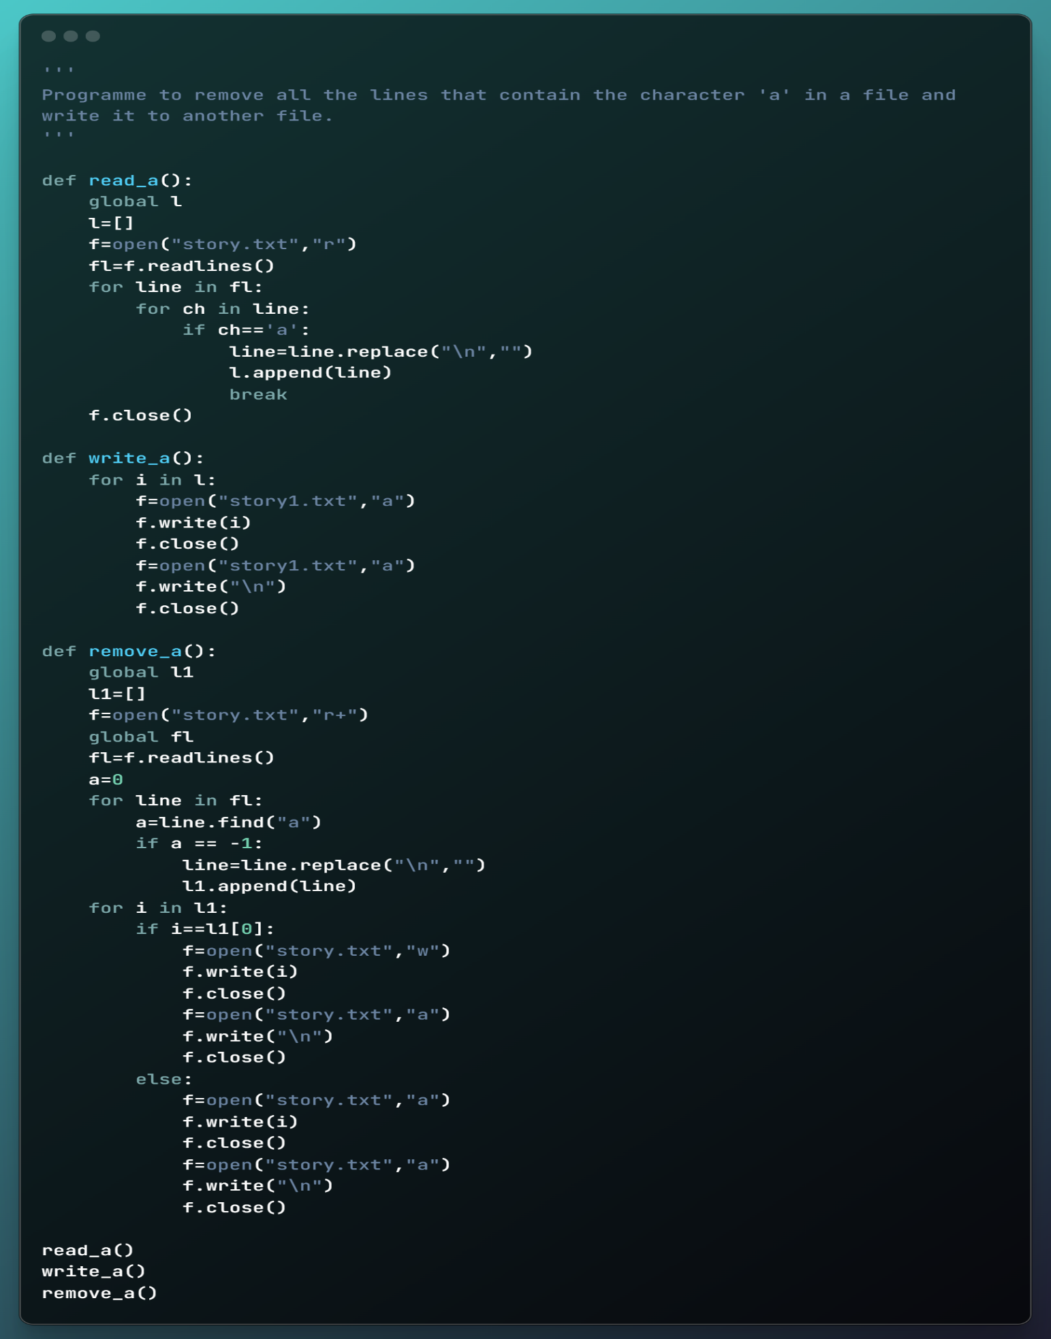

The story.txt file used in this programme is as follows:



Output 14:

After running the programme, story.txt read:



While the newly formed story1.txt file read :



#Program 15:

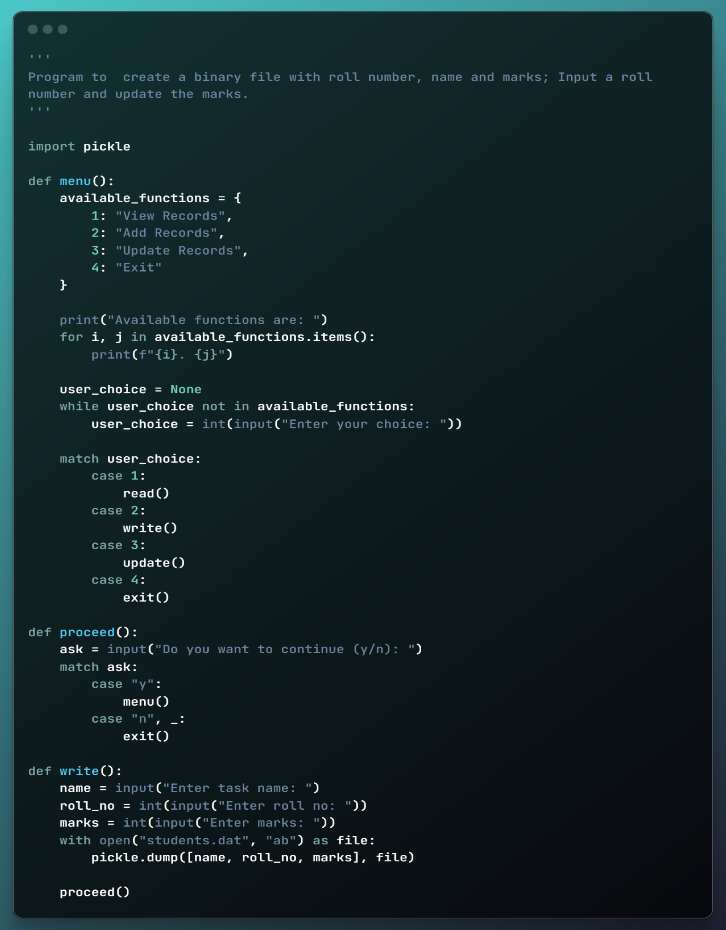

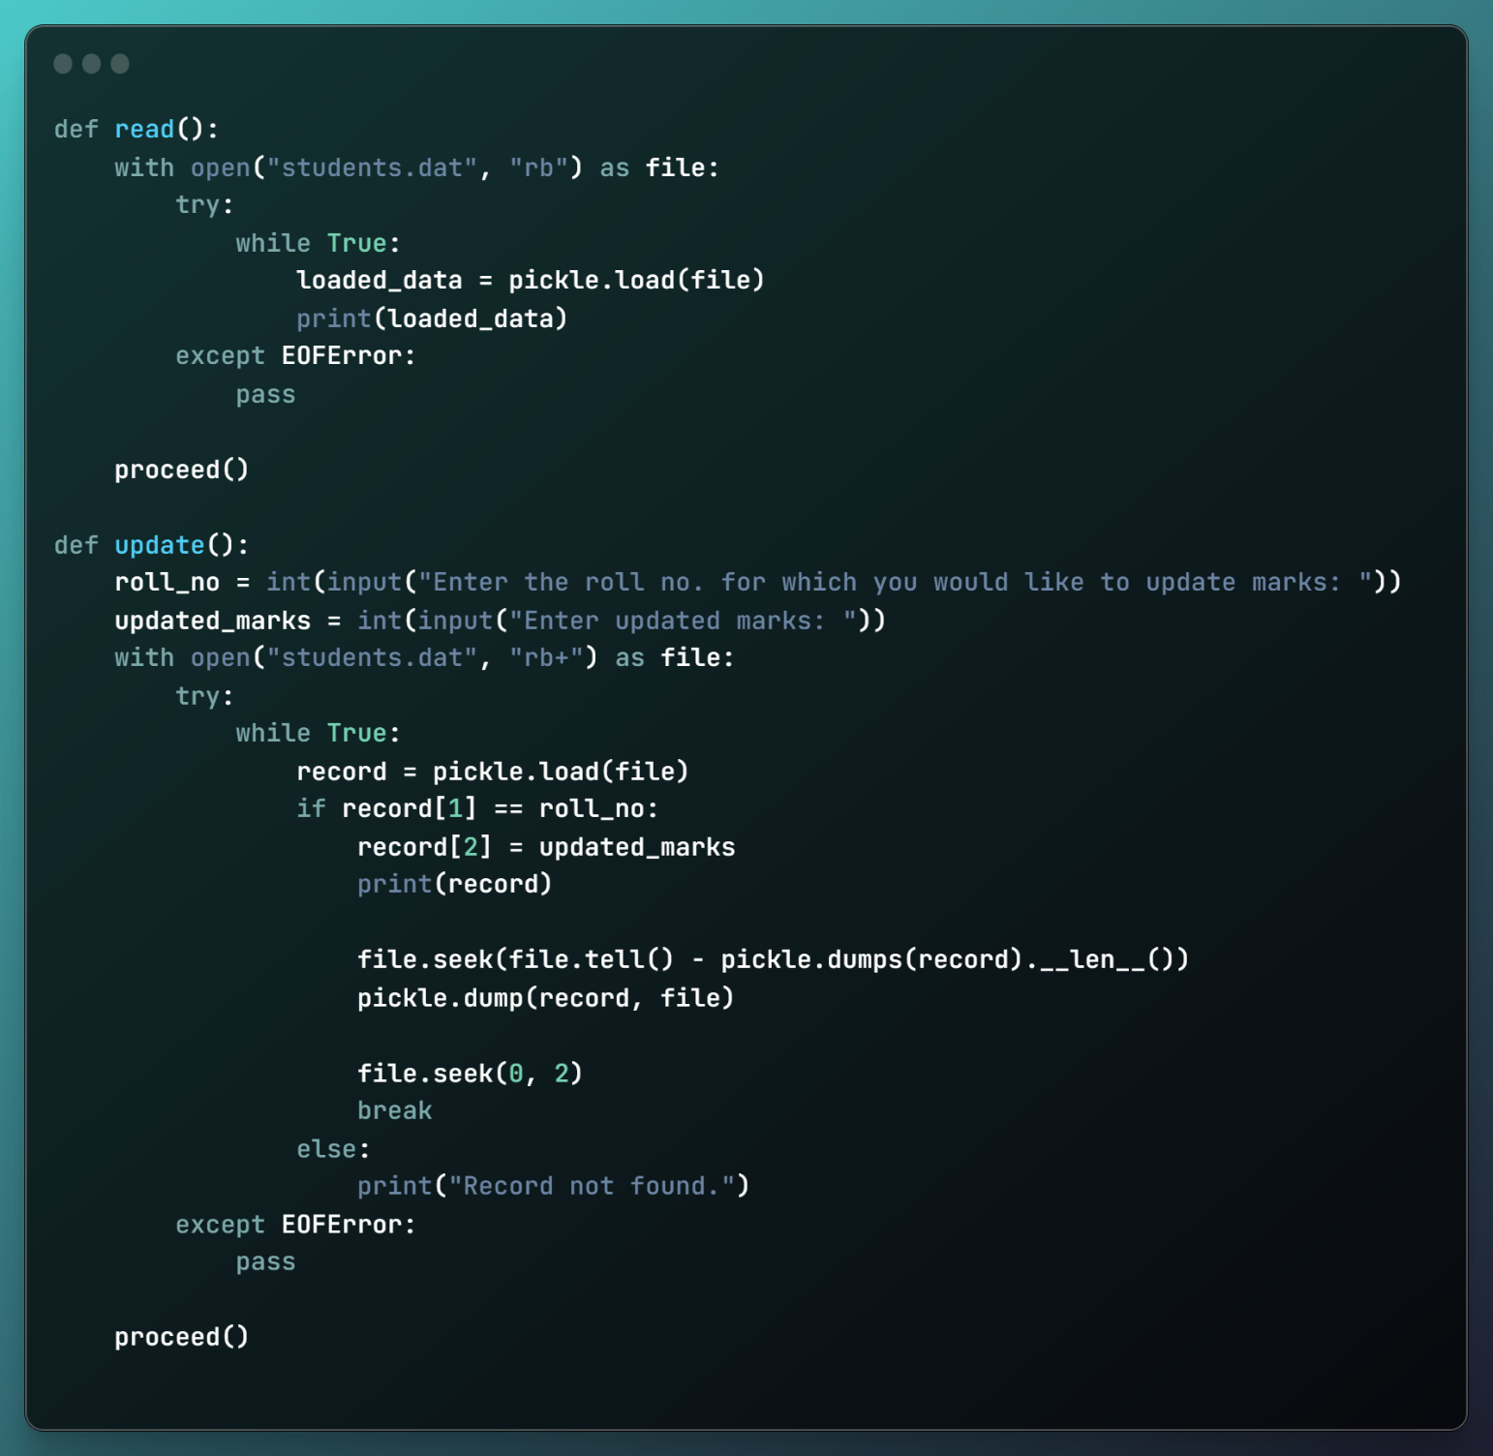

Output 15:

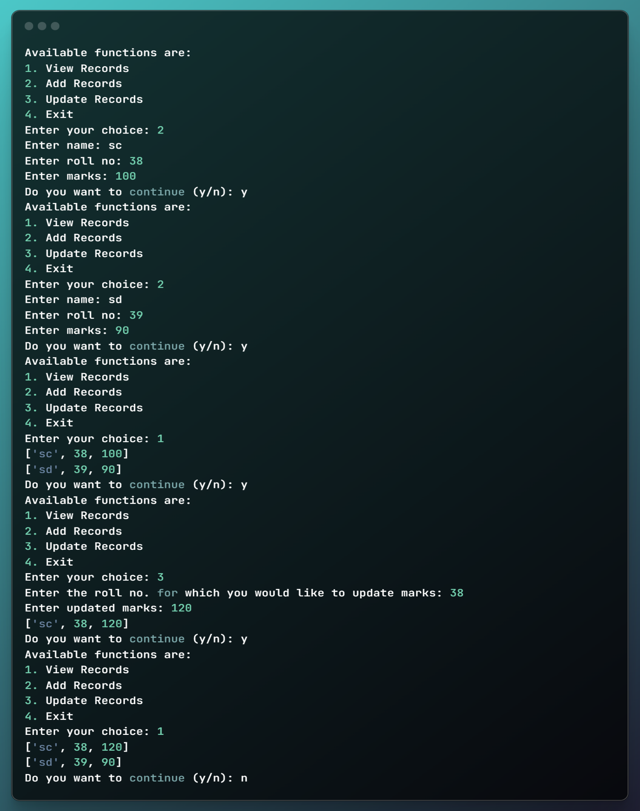

#Program 16:

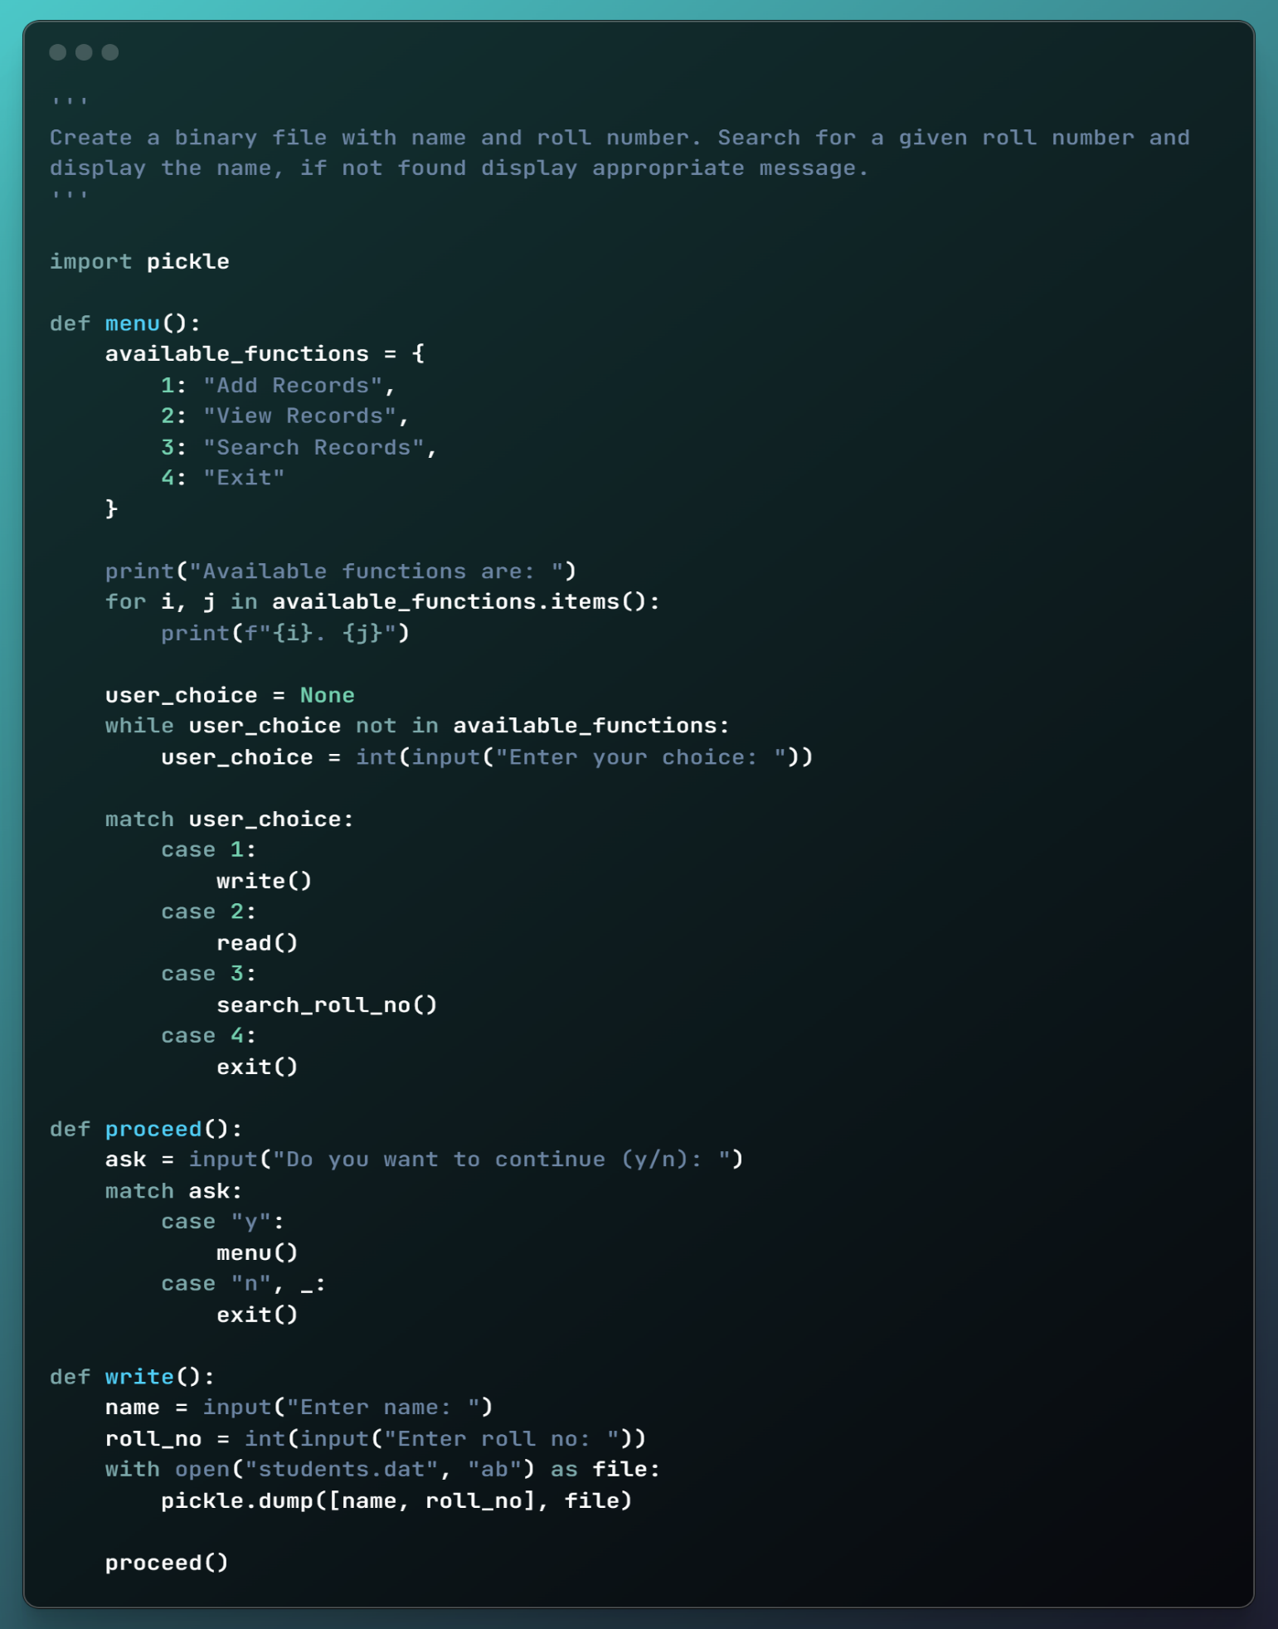

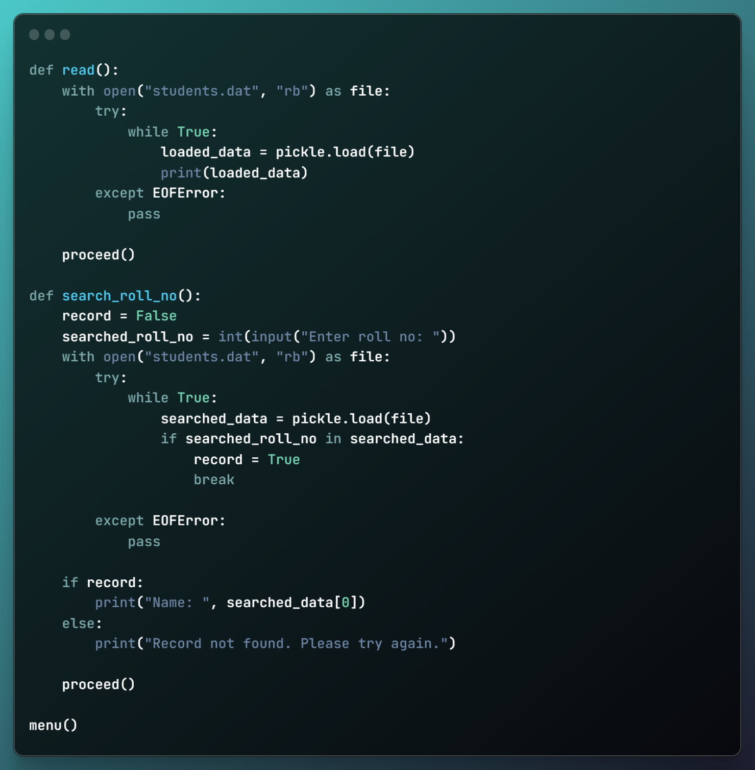

Output 16:

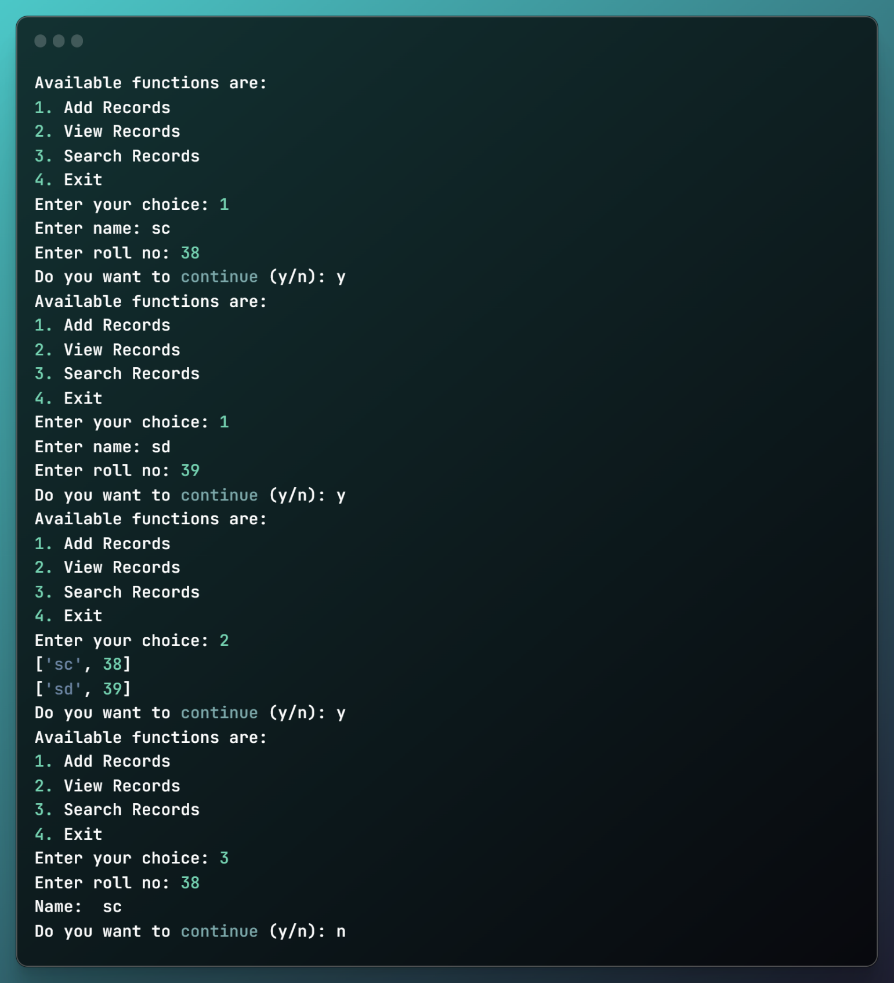

#Program 17:

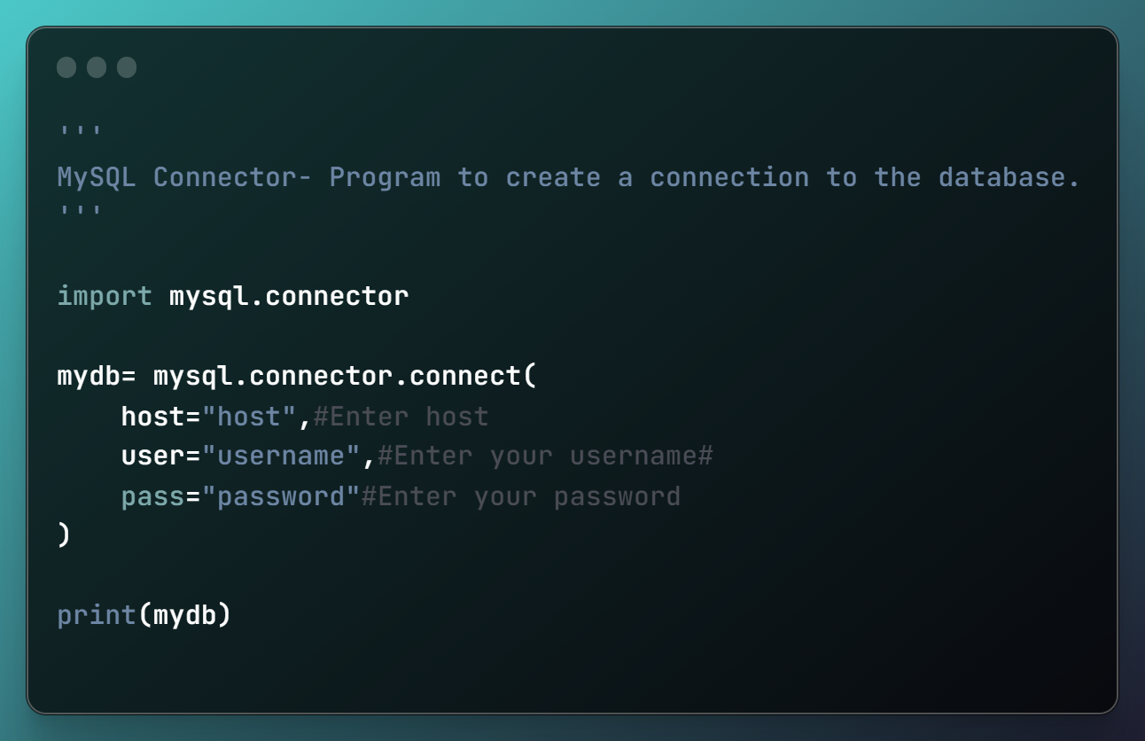

Output 17:

If executed without error, the connection is established.

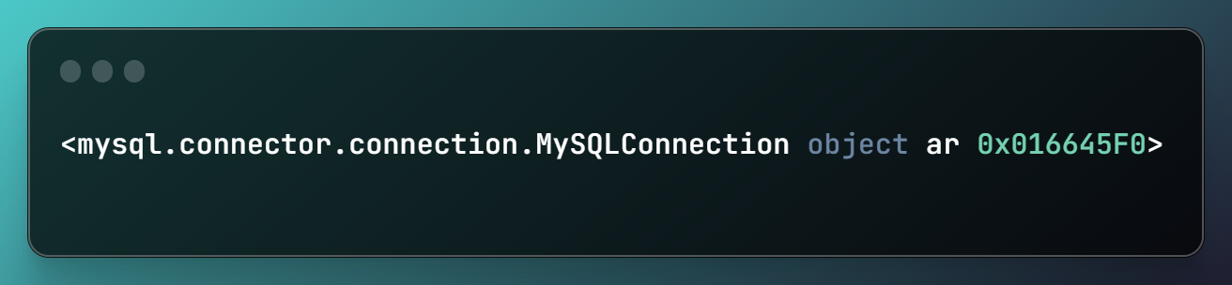

#Program 18: 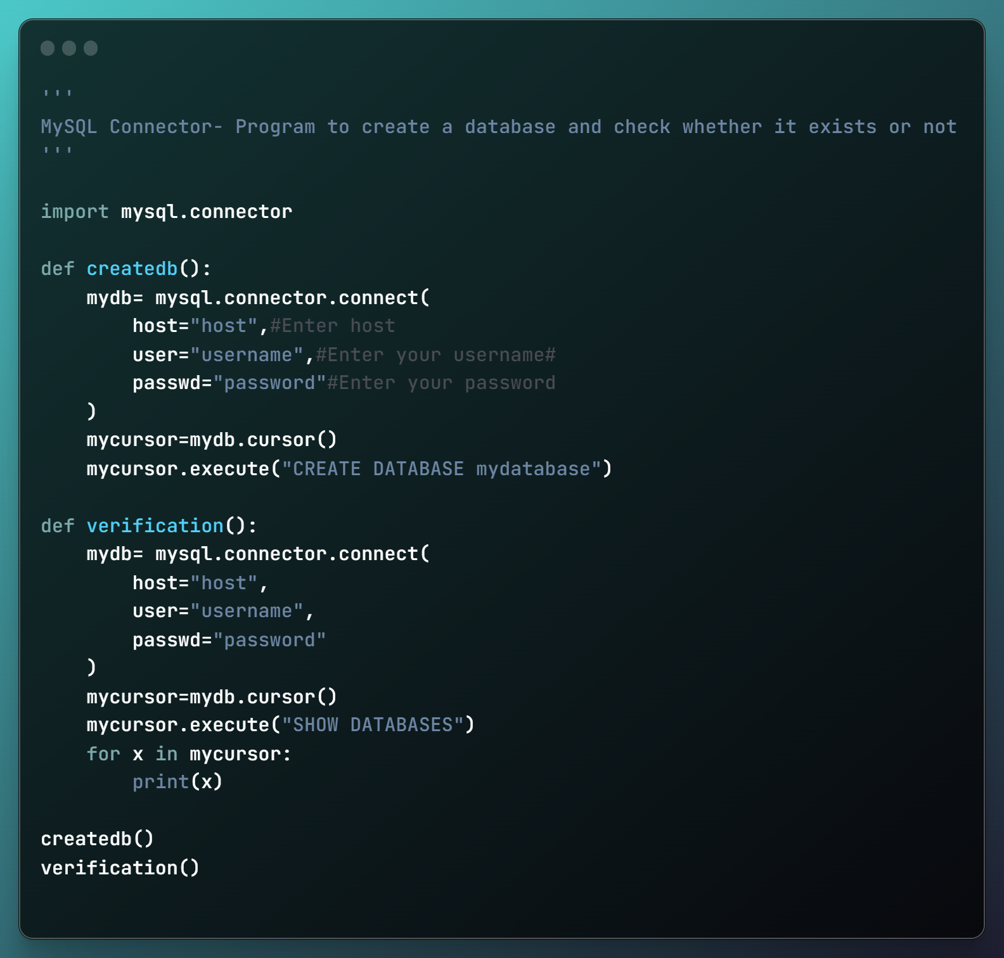

Output 18:

The createdb () creates a database while the verification() shows:

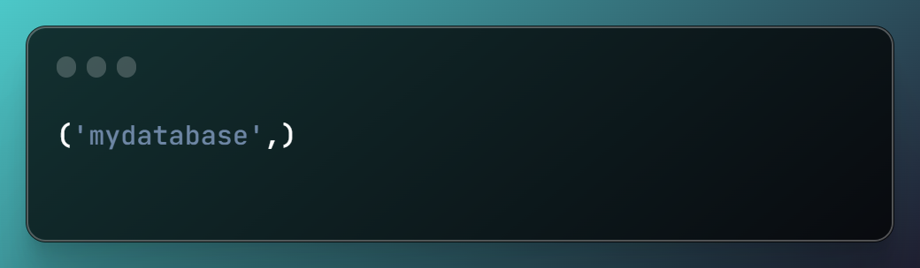

#Program 19:

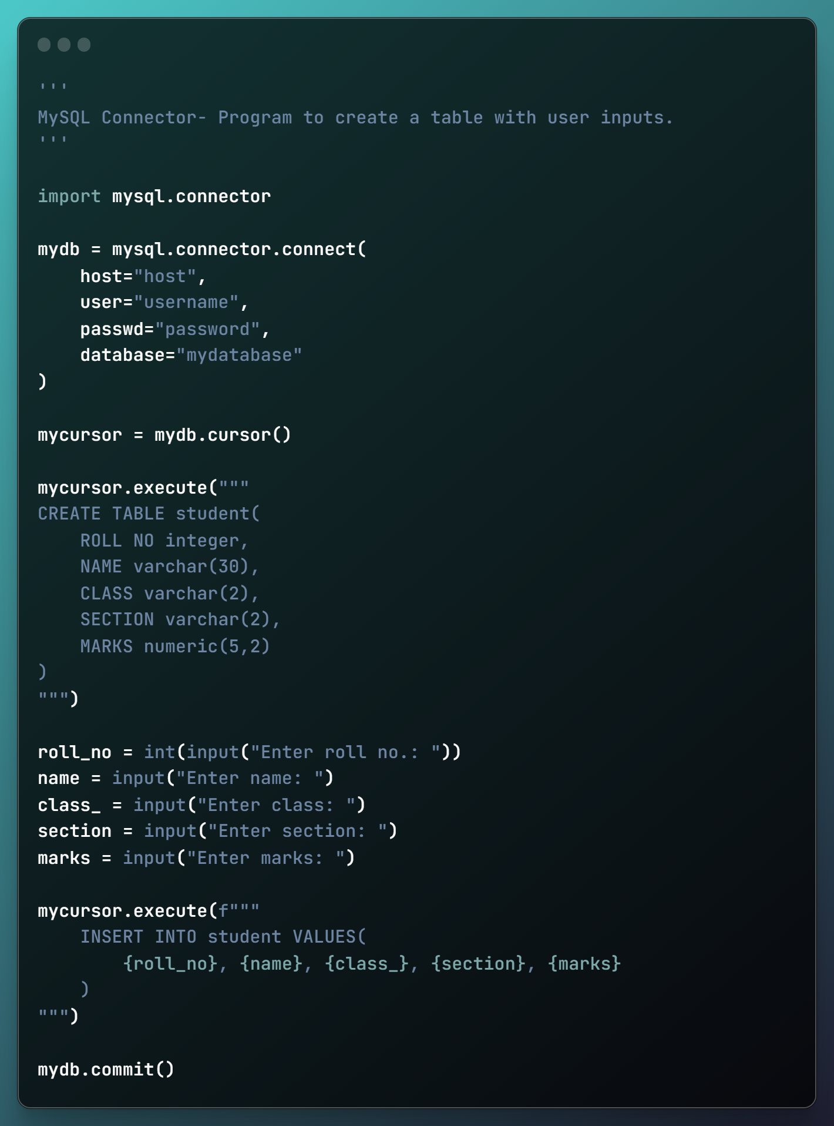

Output 19:

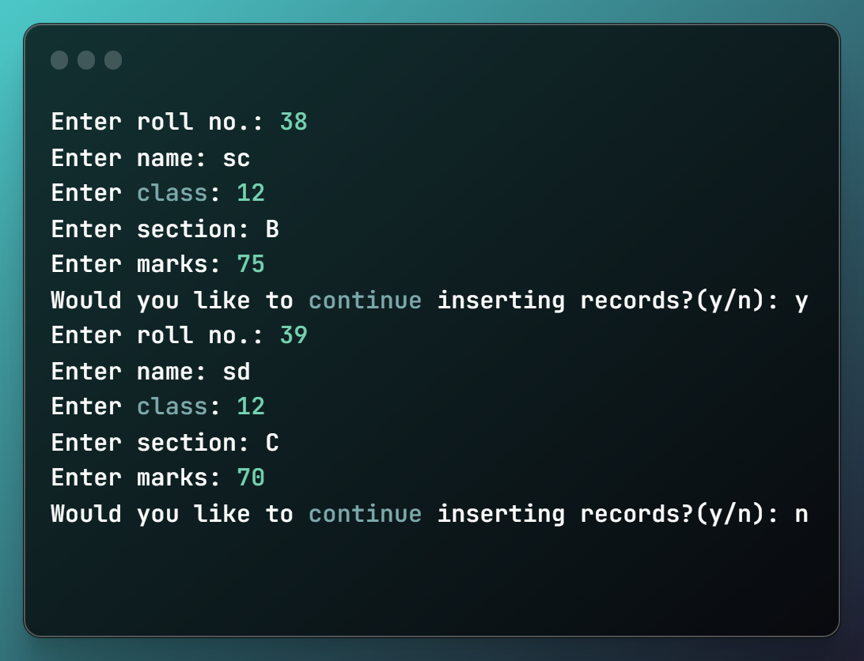

User inputs will be entered as a new record in the table ,here, student.

The table afterwards will appear as follows:

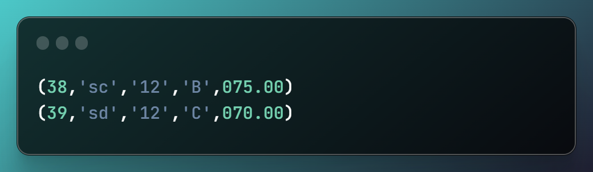

#Program 20:

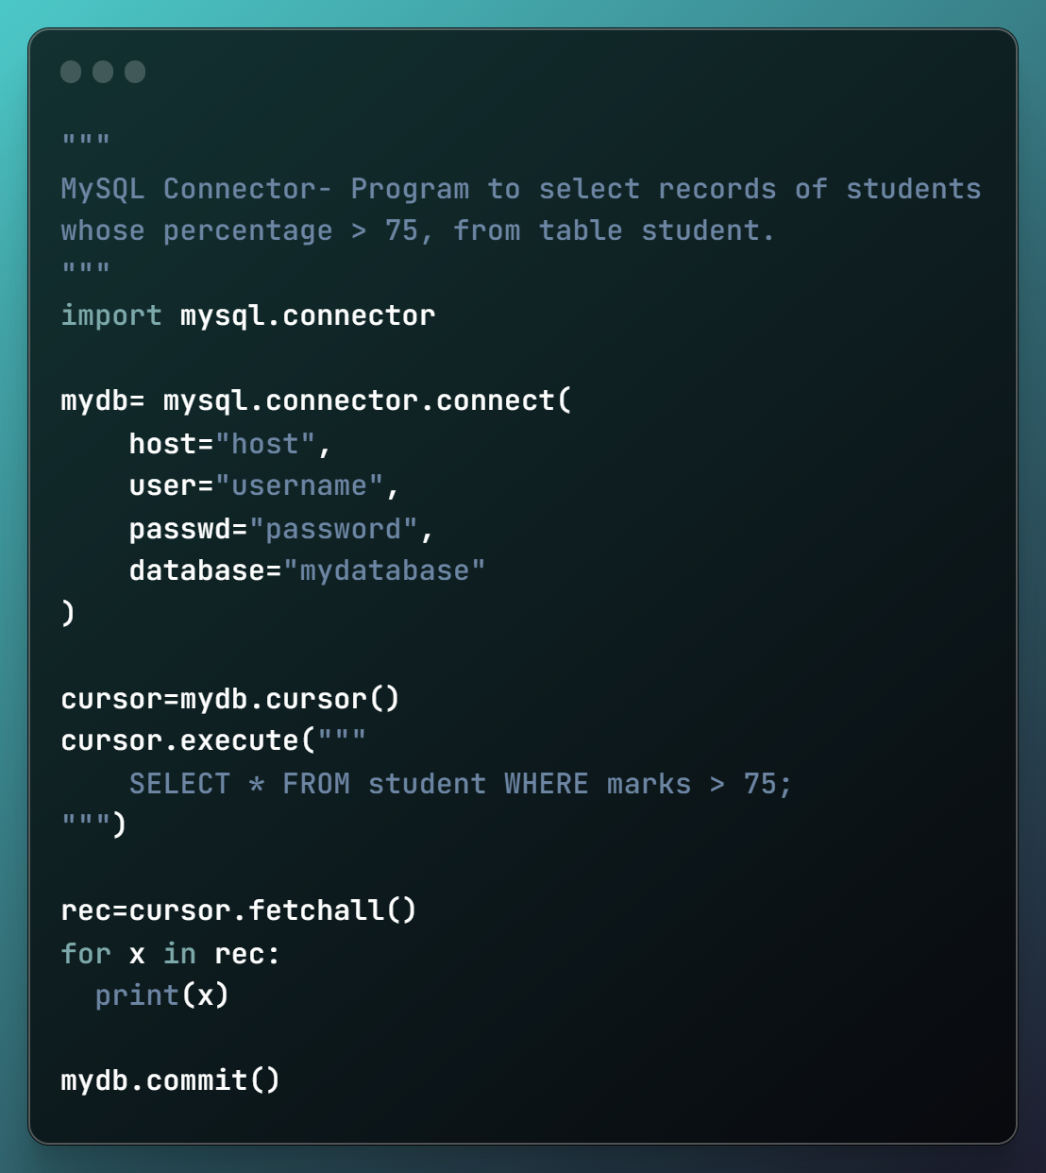

Output 20:

If the table consists of the following records:

(38,'sc','12','B',080.00)

(39,'sd','12','C',070.00)

Then,

For the given programme the output shall read:

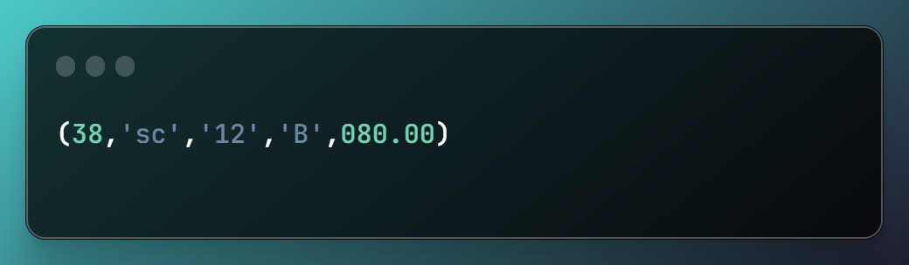

=========================================

**MySQL**

|  |  |  |
| --- | --- | --- |
| S. No. | Content | Pg no. |
| 1 | SET- 1 | 45 |
| 2 | SET- 2 | 46-47 |
| 3 | SET- 3 | 48-49 |
| 44 | SET- 4 | 50-51 |
| 5 | SET- 5 | 52-53 |

**INDEX**

TABLE - 1

**GAMES**

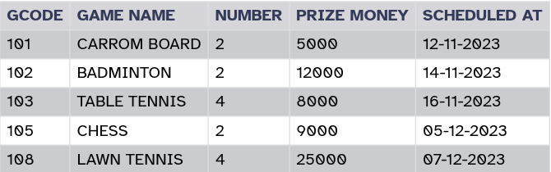

1. Select count(distinct number) from games;   
   **Output**: 2
2. Select max(“scheduled at”), min(“scheduled at”) from games;   
   **Output**:

|  |  |
| --- | --- |
| **MAX(Scheduled at)** | **MIN(Scheduled at)** |
| 07-12-2023 |  |

3. Select avg(“prize money”) from games;   
 **Output**: 11800

4. Select * from games where number = 2 orderby gcode desc;   
 **Output:**

|  |  |  |  |  |
| --- | --- | --- | --- | --- |
| **GCODE** | **GAME NAME** | **NUMBER** | **PRIZE MONEY** | **SCHEDULTED AT** |
| 105 | CHESS | 2 | 9000 | 05-12-2023 |
| 102 | BADMINTON | 2 | 12000 | 14-11-2023 |
| 101 | CARROM BOARD | 2 | 5000 |  |

5. Select count(gcode) from games where “prize  money”> 10000 ;   
 **Output:** 2

 

**SET- 1**

TABLE – 2

1. SQL Query to create the table   
      
   Create table EMP(   
    EMPNO integer,    
    NAME varchar(30),    
    DEPT varchar(10),    
    DESIGNATION varchar(5),    
    GENDER varchar(2),    
    SALARY integer,    
    CITY varchar(10)   
   );   
   **Output**: A table as defined above is formed, if no error is met during the given command's execution.
2. Insert into EMPNO values (1, 'Deepika', ‘Sales’, 'Manager', 'F', 55000, 'Delhi');   
   Insert into EMPNO values (2, 'Gagan', 'Accounts', 'Operator', 'M', 20000, 'Mumbai);   
   Insert into EMPNO values (3, 'Neelam', 'Computers', 'Operator', 'F', 22000, 'Kolkata');   
   Insert into EMPNO values (4, 'Vijay', 'Sales', 'Manager', 'M', 45000, 'Cochin');   
   Insert into EMPNO values (5, 'Sunitha', 'Accounts', 'Operator', 'F', 18000, 'Calicut');   
   Insert into EMPNO values (5, 'Rajesh', 'Sales', 'Clerk', 'M', 48000, 'Chennai');   
   Insert into EMPNO values (7, 'Kunal, 'Computers', 'Manager', 'M', 51000, 'Delhi');  
   Select * from EMP;

 

|  |  |  |  |  |  |  |
| --- | --- | --- | --- | --- | --- | --- |
| **EMPNO** | **NAME** | **DEPT** | **DESIGNATION** | **GENDER** | **SALARY** | **CITY** |
| 1 | Deepika | Sales | Manager | F | 55000 | Delhi |
| 2 | Gagan | Accounts | Operator | M | 20000 | Mumbai |
| 3 | Neelam | Computers | Operator | F | 22000 | Kolkata |
| 4 | Vijay | Sales | Manager | M | 45000 | Cochin |
| 5 | Sunitha | Accounts | Operator | F | 18000 | Calicut |
| 5 | Rajesh | Sales | Clerk | M | 48000 | Chennai |
| 7 | Kunal | Computers | Manager | M | 51000 | Delhi |

1. Update EMP set empno=6 where designation = 'Sales';   
   Select * from EMP;   
   **Output**:

|  |  |  |  |  |  |  |
| --- | --- | --- | --- | --- | --- | --- |
| **EMPNO** | **NAME** | **DEPT** | **DESIGNATION** | **GENDER** | **SALARY** | **CITY** |
| 1 | Deepika | Sales | Manager | F | 55000 | Delhi |
| 2 | Gagan | Accounts | Operator | M | 20000 | Mumbai |
| 3 | Neelam | Computers | Operator | F | 22000 | Kolkata |
| 4 | Vijay | Sales | Manager | M | 45000 | Cochin |
| 5 | Sunitha | Accounts | Operator | F | 18000 | Calicut |
| 6 | Rajesh | Sales | Clerk | M | 48000 | Chennai |
| 7 | Kunal | Computers | Manager | M | 51000 | Delhi |

1. Select gender from emp where dept is not null;

**Output**:

|  |
| --- |
| **GENDER** |
| F |
| M |
| F |
| M |
| F |
| M |
| M |

1. Select sum(salary) from emp where salary >= 45000;

**Output**: 199000

**SET- 2**

**Output**:

**EMP**

|  |  |  |  |  |  |  |
| --- | --- | --- | --- | --- | --- | --- |
| **EMPNO** | **NAME** | **DEPT** | **DESIGNATION** | **GENDER** | **SALARY** | **CITY** |
| 1 | Deepika | Sales | Manager | F | 55000 | Delhi |
| 2 | Gagan | Accounts | Operator | M | 20000 | Mumbai |
| 3 | Neelam | Computers | Operator | F | 22000 | Kolkata |
| 4 | Vijay | Sales | Manager | M | 45000 | Cochin |
| 5 | Sunitha | Accounts | Operator | F | 18000 | Calicut |
| 5 | Rajesh | Sales | Clerk | M | 48000 | Chennai |
| 7 | Kunal | Computers | Manager | M | 51000 | Delhi |

1. Update EMP set empno=6 where designation = 'Sales';   
   Select * from EMP;   
   **Output:**

|  |  |  |  |  |  |  |
| --- | --- | --- | --- | --- | --- | --- |
| **EMPNO** | **NAME** | **DEPT** | **DESIGNATION** | **GENDER** | **SALARY** | **CITY** |
| 1 | Deepika | Sales | Manager | F | 55000 | Delhi |
| 2 | Gagan | Accounts | Operator | M | 20000 | Mumbai |
| 3 | Neelam | Computers | Operator | F | 22000 | Kolkata |
| 4 | Vijay | Sales | Manager | M | 45000 | Cochin |
| 5 | Sunitha | Accounts | Operator | F | 18000 | Calicut |
| 6 | Rajesh | Sales | Clerk | M | 48000 | Chennai |
| 7 | Kunal | Computers | Manager | M | 51000 | Delhi |

1. Select gender from emp where dept is not null;

**Output**:

|  |
| --- |
| **GENDER** |
| F |
| M |
| F |
| M |
| F |
| M |
| M |

1. Select sum(salary) from emp where salary >= 45000;

**Output**: 199000

TABLE – 3

**COLLEGE**   
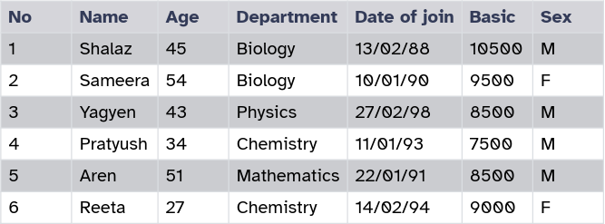

1. Update COLLEGE set basic = 10500 where date of join > ‘01/02/89’ and age > 50;   
   Select * from college where date of join > ‘01/02/89’ and age > 50 ;

**Output:**

|  |  |  |  |  |  |  |
| --- | --- | --- | --- | --- | --- | --- |
| **No** | **Name** | **Age** | **Department** | **Date of join** | **Basic** | **Sex** |
| 2 | Sameera | 54 | Biology | 10/01/90 | 10500 | F |
| 5 | Aren | 51 | Mathematics | 22/01/91 | 10500 | M |

1. Select Name, Age and Basic from COLLEGE where department in ('Physics', 'Chemistry');

**Output**:

|  |  |  |
| --- | --- | --- |
| **Name** | **Age** | **Basic** |
| Yagyen | 43 | 8500 |
| Pratyush | 34 | 7500 |
| Reeta | 27 |  |

1. Delete from College where name= 'Shalaz';

**SET- 3**

**Output**:

|  |  |  |  |  |  |  |
| --- | --- | --- | --- | --- | --- | --- |
| **No** | **Name** | **Age** | **Department** | **Date of Join** | **Basic** | **Sex** |
| 2 | Sameera | 34 | Biology | 10/01/90 | 9500 | F |
| 3 | Yagyen | 43 | Physics | 27/02/98 | 8500 | M |
| 4 | Pratyush | 34 | Chemistry | 11/01/93 | 7500 | M |
| 5 | Aren | 51 | Mathematics | 22/01/91 | 8500 | M |
| 6 | Reeta | 27 | Chemistry | 14/02/94 | 9000 | F |

1. Insert into college values (11, 'Saurav', 50, 'Biology', '18/05/93', 12000, 'M');

**Output**:

|  |  |  |  |  |  |  |
| --- | --- | --- | --- | --- | --- | --- |
| **No** | **Name** | **Age** | **Department** | **Date of Join** | **Basic** | **Sex** |
| 2 | Sameera | 34 | Biology | 10/01/90 | 9500 | F |
| 3 | Yagyen | 43 | Physics | 27/02/98 | 8500 | M |
| 4 | Pratyush | 34 | Chemistry | 11/01/93 | 7500 | M |
| 5 | Aren | 51 | Mathematics | 22/01/91 | 8500 | M |
| 6 | Reeta | 27 | Chemistry | 14/02/94 | 9000 | F |
| 11 | Saurav | 50 | Biology | 18/05/93 | 12000 | M |

1. select distinct(department) from college;   
   **Output**:

|  |
| --- |
| **Department** |
| Biology |
| Physics |
| Chemistry |
| Mathematics |

TABLE - 4

**EMPLOYEE**   
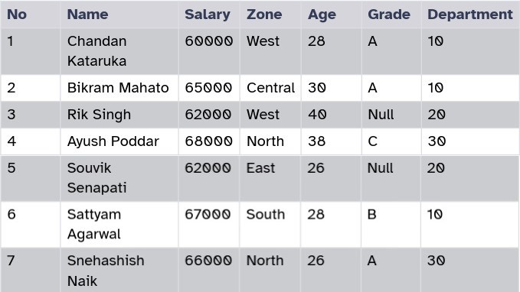

1. select sum(Salary) from Employee where Zone='West';

**Output:** 122000

1. select count(no) from employee where Grade is Null;

**Output**: 2

1. select count(grade) from Employee;

**Output:** 5

1. select zone, salary from Employee order by salary desc group by zone;

**SET- 4**

**Output:**  

|  |  |
| --- | --- |
| **Zone** | **Salary** |
| North | 68000 |
| North | 66000 |
| South | 67000 |
| Central | 65000 |
| West | 62000 |
| West | 60000 |
| East | 62000 |

1. drop table employee;

**Output:** With this command, the table itself is dropped i.e. deleted ……….from the database.

**SET- 5**

TABLE - 5

**CABHUB**

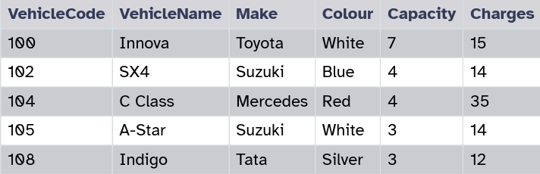

**CUSTOMER**

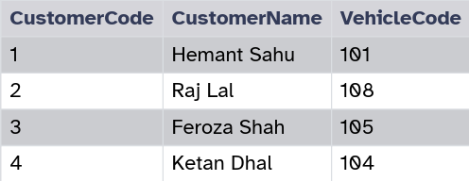

1. select VehicleName, Capacity from Cabhub c, Customer s where c.VehicleCode = s.VehicleCode and c.capacity < 4;   
   **Output**:

|  |  |
| --- | --- |
| **VehicleName** | **Capacity** |
| A-Star | 3 |
| Indigo | 3 |

=========================================

1. select VehicleCode, VehicleName, Make from Cabhub, Customer where Cabhub.VehicleCode = Customer.VehicleCode and Cabhub.Charges > 13;   
   **Output**:

|  |  |  |
| --- | --- | --- |
| **VehicleCode** | **VehicleName** | **Make** |
| 104 | C Class | Mercedes |
| 105 | A-Star | Suzuki |

1. desc Customer;   
   **Output**:

|  |  |  |  |  |  |
| --- | --- | --- | --- | --- | --- |
| **Field** | **Type** | **Null** | **Key** | **Default** | **Extra** |
| CustomerCode | int | NO | PRI | NULL |  |
| CustomerName | Varchar(30) | YES |  | NULL |  |
| VehicleCode | int | NO |  | NULL |  |

1. select Cabhub.VehicleCode, CustomerCode, VehicleName from Cabhub, Customer orderby Cabhub.make where Cabhub.VehicleCode = Customer.VehicleCode;   
   **Output**:

|  |  |  |
| --- | --- | --- |
| **VehicleCode** | **CustomerCode** | **VehicleName** |
| 104 | 4 | C Class |
| 105 | 3 | A-Star |
| 108 | 2 | Indigo |

1. Alter table Customer modify CustomerName varchar(30) NOT NULL;   
   desc Customer;   
   Output:

|  |  |  |  |  |  |
| --- | --- | --- | --- | --- | --- |
| **Field** | **Type** | **Null** | **Key** | **Default** | **Extra** |
| CustomerCode | int | NO | PRI | NULL |  |
| CustomerName | Varchar(30) | NO |  | NULL |  |
| VehicleCode | int | NO |  | NULL |  |

